Table of Contents

Cover Page

Summary of Personnel, Commitments, and Costs 2

Scientific/Technical/Management Section 3

Objectives and Significance of Proposed Research 3

Impact of Proposed Research 4

Preliminary Results 5

Technical Approach and Methodology 6

Relevance of Proposed Research 9

Outline of Plan of Work 10

Expected Contributions 11

Figures 12

Access to Frey’s QCD dataset 17

References 18

Facilities and Equipment 23

Curriculum Vitae – Principal Investigator 24

Curriculum Vitae – Co-Investigator 27

Current and Pending Support 28

Statements of Commitment 29

Research Budget Summary and Details 32

Reprint of Withers P. and Neumann G. A. (2001) end
Engimatic Northern Plains of Mars, Nature, 410, 651.

Summary of Personnel, Commitments, and Costs

Name Role Time Commitment Unburdened Salary
(fraction of a work year) (per year)

H. J. Melosh PI 0.05 $ 0
P. Withers Co-I and Science PI 0.5 $ 12000

Collaborators: W. B. Banerdt and G. A. Neumann

Commitments are identical for all years of the proposed research.

Professor Melosh’s time commitment, valued at approximately $4000 per year, will be supported by his academic position at the University of Arizona. This will reduce the cost to NASA of this grant proposal.

Scientific/Technical/Management Section

Objectives and Significance of Proposed Research

Basic objective - Continue our investigations of tectonic ridges in the northern plains of Mars using MOLA data, theoretical models, and Viking and MOC images.

Expected significance – The proposed research will enhance our understanding of the tectonic history of Mars, the origin of the northern plains, and the possibility of an ancient northern ocean.

Reasons for proposing to this program – This proposed research is very relevant to NASA’s planetary program in general and MDAP in particular. Owing to citizenship restrictions, neither NASA nor NSF graduate student fellowships are open to Withers. The requested funding in this proposal is largely to support Withers.

Task 1 – Map ridges in the northern plains, and their properties, using MOLA data. Variations in ridge properties will indicate variations in lithospheric structure or stress regime.

Task 2 – Examine photographic images of these ridges. Viking prints and MOC images may reveal fine-scale structure on these ridges, occurrences of which can be correlated with other ridge properties.

Task 3 – Study the relationship between these ridges and a population of subdued craters, visible in MOLA images of the northern plains and mapped as quasi-circular depressions, or QCDs, by Frey and colleagues, which is not seen in Viking images. This will constrain the pre-Amazonian history of the northern plains, and the degraded topography of the craters will be used to estimate the extent to which the ridges have undergone modification.

Frey’s derived data products will be made available to us for this proposed research. Frey will not provide any proprietary data. See “Access to Frey’s QCD dataset” section.

Task 4 – Calculate regional strain magnitudes and directions in the northern plains using the results of Tasks 1, 2, and 3. This will provide a constraint on tectonic models of the northern plains.

Task 5 – Model stress and strain in the northern plains. Adjusting the model parameters to best fit the results of Task 4 will constrain the nature of the lithospheric structure and loading in the vicinity of the northern plains.

With the exception of Frey’s derived data products, publicly available data will be used to perform this proposed research.

Impact of Proposed Research

Figure 1 shows a Viking photomosaic of the northern part of the Utopia impact basin. Craters are visible on a mottled terrain. Figure 2 shows a digital terrain model generated from gridded MOLA data available from the Planetary Data System (PDS) (Smith et al. 1999). Many new features are visible, including a second, subdued, population of craters and a network of ridges. The shallow slopes of the ridges and subdued craters, and consequent lack of shadows, explain why they are not visible on photographic images. Improved global photomosaics, e.g. from the MOC and THEMIS instruments, they will suffer from the same handicaps in imaging these shallow features. MOLA has no such limitations.

MOLA data reveal that the northern plains of Mars are the flattest known surface in the solar system and that they are criss-crossed by ridges of likely tectonic origin (Smith et al., 1998; Aharonson et al., 1998; Withers and Neumann, 2000, 2001a, b; Head et al., 2001a, b, c). High-resolution shaded topographic images of the polar basin, available at http://ltpwww.gsfc.nasa.gov/tharsis/mola.html, show the ridges clearly. A global digital terrain model at 1/32º resolution was made publicly available via the PDS in March 2001. This, and any digital terrain models of improved resolution made available during the duration of this proposed research, will be the primary dataset used.

The causes of the youth and smoothness of the northern plains are still debated (Smith et al., 1998, and references therein; Zuber et al., 2000). The network of ridges is the dominant, indeed the only, tectonic feature throughout this enigmatic region, which covers a quarter of the planet. The most complete survey of martian ridges to date, which mapped over 16,000 ridges, commented that “as is well known, the northern plains have few ridges” and was not able to identify the network of ridges revealed by MOLA (Chicarro et al., 1985).

Wrinkle ridges, a subset of ridges, are one of the most commonly observed, yet least understood, classes of planetary structure (e.g. Schultz, 2000; Watters, 1992). They occur on all the terrestrial planets, including Mercury (e.g. Strom et al., 1975), Venus (e.g. Kreslavsky and Basilevsky, 1998; Bilotti and Suppe, 1999), Earth (e.g. Plescia and Golombek, 1986; Watters, 1988), the Moon (e.g. Lucchitta, 1976, 1977; Sharpton and Head, 1988), and Mars (e.g. Plescia, 1991, 1993; Watters and Robinson, 1997). Observations of martian wrinkle ridges have been used to constrain the planetary thermal history (e.g. Banerdt et al., 1992), tectonic history (e.g. Tanaka et al., 1991; Schultz and Tanaka, 1994), volcanic history (e.g. Watters, 1993), impact history (e.g. Wilhelms and Squyres, 1984; Chicarro et al., 1985), lithospheric structure (e.g. Zuber and Aist, 1990), and changes in orbital and rotational dynamics (e.g. Melosh, 1989; Grimm and Solomon, 1986; Schultz and Lutz, 1988).

This research proposal will map and measure this network of ridges, then use that information to constrain martian tectonic models and the history of the northern plains. A preliminary test of the ancient ocean hypothesis has been published and further tests of shoreline candidates are a natural part of Tasks 1 and 2 (Withers and Neumann, 2001a).
Preliminary Results

In earlier work, we began to investigate the distribution and nature of these ridges and published a test of the ancient northern ocean hypothesis (Withers and Neumann, 2000, 2001a, b).

Task 1 – Ridge locations have been mapped and we have begun to measure ridge properties. Figure 3 shows ridges that we have mapped in the northern plains (black) and also wrinkle ridges mapped globally by Watters (1993) using Viking images (white). The ridges have characteristic wrinkle ridge profiles, characteristic lengths of 100s of kilometers, characteristic heights of 100 metres, and characteristic flank slopes on the order of only 1 degree. Ridge spacings vary throughout the northern plains, but are on the order of 100 km.

Task 2 – Guided by Figure 2, several ridges can be seen in Figure 1. We have verified that high-quality prints of Viking images of the ridges, available at the University of Arizona’s Regional Planetary Image Facility, show detail beyond that seen in the more common representations of Viking images, such as the USGS MDIM-2 available online, and have begun to study these.

Task 3 – We have not found any examples of ridges clearly cutting fresh or stealth craters, suggesting that the ridges may predate both populations of craters. However, we have not yet examined other types of ridge-crater interaction, such as those discussed by Sharption and Head (1988). Stealth craters, using the terminology adopted by Head and Kreslavsky, are subdued craters that are easily visible in the MOLA data. They are a subset of Frey’s QCDs.

Task 4 – Regional strain directions are readily apparent from Figure 3. Regional strain magnitudes are harder to estimate. Using the techniques of Golombek et al. (1991) we estimate a regional strain on Lunae Planum, in the southern highlands, of a few x 10⁻³, consistent with Golombek et al. (2001), and about half that in nearby Chryse Planitia, in the northern plains. This surprisingly large decrease over a distance short by comparison with the scale of Tharsis, the source of the stress, is discussed in the Technical Approach and Methodology section.

Task 5 – Figure 4 shows a prediction of compressive strain in the martian lithosphere, performed by Banerdt. Also shown are ridges that we have mapped in the northern plains (white) and wrinkle ridges mapped globally by Watters (1993) using Viking images (red). Many of the ridges are orthogonal to the predicted direction of maximum compressive strain, as expected for wrinkle ridges underlain by thrust faulting. An obvious exception is the family of radial ridges within the Utopia impact basin. These do not have the elevation offsets characteristic of wrinkle ridges underlain by thrust faulting and may instead be shallow compressional features related to the infilling of Utopia (Turtle, personal communication, 2001).

Technical Approach and Methodology

Task 1 – Ridges will be mapped and their morphology studied using gridded MOLA topographic data publicly available from the PDS. Maps of absolute surface slope will be generated. Ridges will stand out as linear regions of greater than background slope and be easily identifiable. Then, in the topographic data, these linear regions will be illuminated across-strike and can be confirmed as ridges, rather than troughs or other features. Then, topographic profiles will be constructed across the ridges using gridded MOLA topographic data, and the height, width, flank slopes, elevation offset, and asymmetry of each ridge will be measured. Using gridded data to construct profiles eliminates the directional bias that would occur from using individual north-south MOLA profiles to study these ridges.

These results will be used to see if there are any distinct classes of ridges within the northern plains, or if all are morphologically similar. Wrinkle ridges, a compressional tectonic landform, are a subset of ridges. Ridges are classified as wrinkle ridges on the basis of their morphology (Watters, 1988, 1993; Schultz, 2000). Distinguishing between tectonic and non-tectonic ridges is clearly important (see Preliminary Results for Task 5). Ridge properties will be compared to those of previously studied wrinkle ridge provinces on Mars and elsewhere in the Solar System.

The presence, or absence, of elevation offsets across wrinkle ridges will let us infer the presence, or absence, of underlying thrust faults and study the depth penetration of these faults. Ridge spacings are greater than those found on the neighbouring known wrinkle ridge provinces (Montesi and Zuber, 2000, 2001; Zuber and Aist, 1990, and references therein). Montesi and Zuber use this observation to calculate crustal thickness in the northern plains.

Task 2 – Using the high-quality prints of Viking images available at the University of Arizona’s Regional Planetary Image Facility and MOC images available via the PDS, we will classify ridge morphologies as seen in photographic images. Schultz (2000) summarizes some of the existing classification schemes.

The detail visible in these Viking prints is significantly greater than the detail visible in more common representations of Viking images, especially photomosaics. Due to their shallow slopes, not all the ridges are visible in even the best Viking prints, but the Viking prints will provide a nominal resolution several times better than that of the gridded MOLA data. We will examine ridges first identified in MOLA data rather than reproducing the mapping work of Chicarro et al. (1985) and Watters (1993). We have not identified fine-scale structure, such as the “wrinkle” of wrinkle ridges, in the km-scale resolution gridded MOLA data. Such detail might be visible in the Viking prints or the ridges might lack fine-scale structure. If the latter is true, then we can draw conclusions about the modification that the ridges have undergone since their formation.

MOC images, with typical widths of a km, typical lengths of several tens of km, and metre-scale resolution may show much finer detail than MOLA is capable of resolving. However, image coverage is sparse and the ridges, many of which appear at least partially buried, may not stand out clearly in MOC images. Nonetheless, a careful survey is warranted.

Task 3 – In their studies of QCDs on Mars, Frey and colleagues have produced a dataset of both fresh and subdued craters (Frey et al. 2000, 2001a, b). Figure 5, prepared by Jim Roark, overlays these QCDs on a shaded relief map. QCDs are identified by Frey and colleagues using highly-stretched contoured MOLA data. They are not necessarily easily visible in the shaded relied representation of the data. Frey’s QCD dataset will be made available to us for this proposed research. See “Access to Frey’s QCD dataset” section.

We shall examine MOLA data and Viking images for evidence for crater deformation by ridges, ridges deformed or obliterated by craters, control of ridge position and orientation by craters, and other ridge-crater interactions. If a crater intersects a pre-existing ridge, then part of the ridge will be obliterated by the crater bowl and ejecta blanket. If a ridge intersects a pre-existing crater, then any component of strike-slip faulting may cause lateral offsets in the crater rim and any component of thrust faulting may distort crater circularity or cause vertical offsets in the rim or introduce lobate mounds of material into the interior of fresh craters (Sharpton and Head, 1988). Ridges which appear to have orientations controlled by craters, e.g. a set of ridges that are radial to a crater, indicate that the crater predates the ridges. We will distinguish between fresh craters and craters in various stages of degradation in this work. This will enable us to date the ridges relative to the various types of craters and hence place them in the martian stratigraphy.

We shall also use the morphology of the QCDs, such as the relationship between their depth-diameter ratios and those of fresh craters (Melosh, 1989; Garvin et al. 1998, 1999, 2000), to constrain the amount of deposition that has modified the ridges. This will be useful for Task 4.

Task 4 – Strain directions in the northern plains can be easily obtained from wrinkle ridge orientations. Using the technique of Golombek et al. (1991), the topography of an unmodified wrinkle ridge reveals the strain magnitude. However, as suggested by the preliminary results for Task 3, the apparent burial of the ridges in the northern plains causes this technique to underestimate the actual strain. Despite this limitation, lower limits on strain magnitude will still be a useful constraint on tectonic models. If Task 3 suggests that deposition has been relatively uniform across the northern plains, then the ranking of measured strains is likely to approximate the ranking of actual strains. This will be a further useful constraint.

The results of this task will be used to determine the orientations of the stress field responsible for wrinkle ridge formation at the time of formation. Study of the geometry of these geological structures hence places constraints on the dynamics of the relevant lithospheric deformation mechanisms.

Forthcoming results of the research groups of J. W. Head (especially concerning the deposition of the Vastitas Borealis Formation) and R. A. Schultz (especially concerning the modification of ridges, e.g. Wilkins et al., 2001) may improve our knowledge of the depositional history of the northern plains to the point that reasonable inferences can be made about the pre-modification state of the ridges.

Task 5 – Gravity and topography provide the basic observables from which the loading of the lithosphere can be derived. However, given the non-unique character of potential field interpretation, understanding the partitioning between surface and subsurface components of this load (and thus the structure of the crust and upper mantle) requires additional information. For example, a flexurally-supported surface load and an isostatically maintained edifice could exhibit the same topographic and gravitational signature with the right distribution of density with depth. One clue to this puzzle is the state of stress. A flexural displacement will generate a quite different stress field than an isostatic situation. Estimates of the strain magnitude and direction at the surface (from which the stress can be derived) can be used to provide constraints for computer-generated lithosphere deformation models (Banerdt et al., 1982; Banerdt, 1986; Banerdt et al., 1992)

For this study we will use a thin spherical shell deformation code (Banerdt, 1986; Golombek and Banerdt, 2000) to investigate lithospheric deformation on Mars, particularly around Utopia and northern Tharsis. Various lithospheric structures will be used (e.g., isostatic compensation at different depths, varying amounts of compensation, etc.) and the stresses and strains generated from the present-day topography and gravity will be compared with the strains derived from our analysis of the plains ridges. Note that several lines of evidence support the assumption that present-day topography and gravity are little changed from the early Hesperian (Banerdt and Golombek, 2000; Phillips et al., 2001).

Relevance of Proposed Research

This proposed research will broaden scientific participation in the analysis of the Mars Global Surveyor mission’s dataset. It will enhance the scientific return of the Mars Global Surveyor mission in the following ways:

A – Discovery and characterization of an unsuspected class of tectonic features on the northern plains, an enigmatic region of near global scale, of Mars.
B – Uses these features to constrain global scale tectonic models, with special emphasis on Tharsis.
C – Tests the ancient northern ocean hypothesis.
D – Constrains the resurfacing history of the northern plains of Mars.

Enhancement C indirectly addresses the issue of extra-terrestrial biology, an issue that thoroughly permeates NASA’s plans and aims.

All these enhancements satisfy the Science Goal of the Space Science Enterprise Strategic Plan of “Understand the nature and history of our Solar System” and the two Science Objectives of “Characterize the history, current environment, and resources of Mars, especially the accessibility of water” and “Investigate the processes that underlie the diversity of solar system objects” (Office of Space Science, 1997).

The National Academy of Sciences’ Committee on Lunar and Planetary Exploration (COMPLEX) has advised NASA on NASA’s plans (COMPLEX, 1994). It stated a primary objective for understanding planets to be: Specify the nature and sources of stress that are responsible for the global tectonics of Mars. Enhancements A and B address this objective. It stated another primary objective to be “Advance significantly our understanding of stratigraphic relationships for all solid planets.” Enhancement D addresses this objective.

COMPLEX also posed several key questions for understanding the surfaces and interiors of solid bodies.

It asked: How do global- versus local-scale processes contribute to the observed tectonics? Enhancements A and B address this question.

It asked: How did the Tharsis and Elysium bulges on Mars form, and what do they imply for the state of stress in the crust and the dynamics of the interiors of the planet? Enhancement B addresses this question.

It asked: What are the erosional and sedimentation histories of Mars? Enhancements C and D address this question.

It asked: To what extent have materials been redistributed across their surfaces? Enhancements C and D address this question.
Outline of Plan of Work

First six months

Continue Task 1 Map ridges Withers, Neumann
Continue Task 2 Examine Viking and MOC images Withers
Continue Task 3 Study ridge-crater interactions Withers

Present results at a scientific meeting

Second six months

End Task 1 Map ridges Withers, Neumann
End Task 2 Examine Viking and MOC images Withers
Continue Task 3 Study ridge-crater interactions Withers

Present results at a scientific meeting
Submit paper covering results of Tasks 1 and 2 and latest results from Task 3

Third six months

Continue Task 3 Study ridge-crater interactions Withers
Continue Task 4 Estimate regional strains Withers, Neumann
Continue Task 5 Theoretically model tectonics Banerdt

Present results at a scientific meeting
Submit paper covering latest results from Tasks 3, 4, and 5

Fourth and final six months

End Task 3 Study ridge-crater interactions Withers
End Task 4 Estimate regional strains Withers, Neumann
End Task 5 Theoretically model tectonics Banerdt

Present results at a scientific meeting
Submit paper on final results from this research proposal

Expected Contributions

Melosh (Principal Investigator)

Professor Melosh has studied planetary tectonics for many years. He is an expert on the modelling of tectonic problems and all aspects of impact cratering (Melosh and Raefsky, 1980, 1981; Melosh and Williams, 1989; Melosh, 1989).

• Responsible for quality and direction of research, and for use of awarded funds
• Supervisory role for Withers

Withers (Co-Investigator and Science PI)

Mr. Withers, a PhD candidate, initiated this project during a summer research placement at NASA’s Goddard Space Flight Center. He has presented initial results at several conferences and in the peer-reviewed literature (Withers and Neumann, 2000, 2001a, b).

• Lead role in proposal preparation
• Responsible for day-to-day progress in most Tasks

Banerdt (Collaborator)

Dr. Banerdt, a member of the MOLA Science Team, wrote the standard reference on martian tectonics (Banerdt et al., 1992). He uses theoretical tectonic models to constrain lithospheric structure and loading on the terrestrial planets (Banerdt et al., 1982; Banerdt, 1986; Banerdt et al., 1992).

• Use theoretical models to predict stress and strain for Task 5

Neumann (Collaborator)

Dr. Neumann, a member of the MOLA Science Team, leads the processing of raw MOLA data into a scientifically useful product. He supervised the summer research placement of Withers and is intimately familiar with the MOLA data.

• Continue to guide Withers through the use of large gridded data sets
• Assist in automating the measurement of ridge properties for Tasks 1 and 4
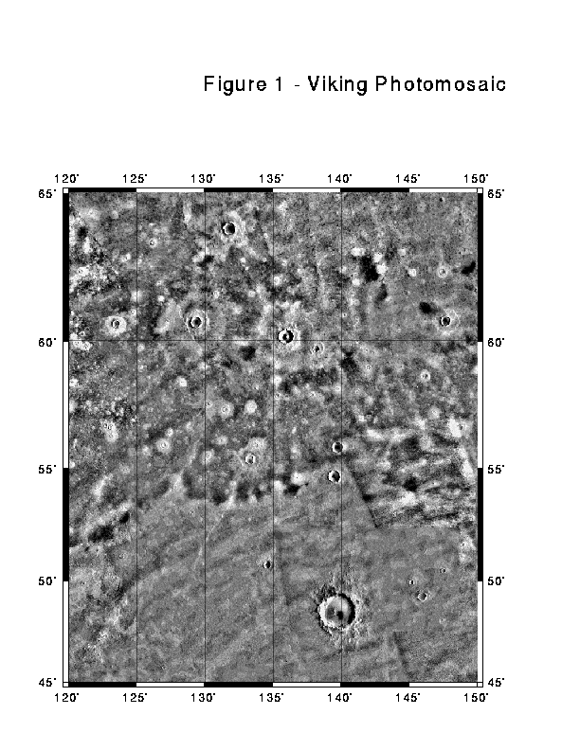
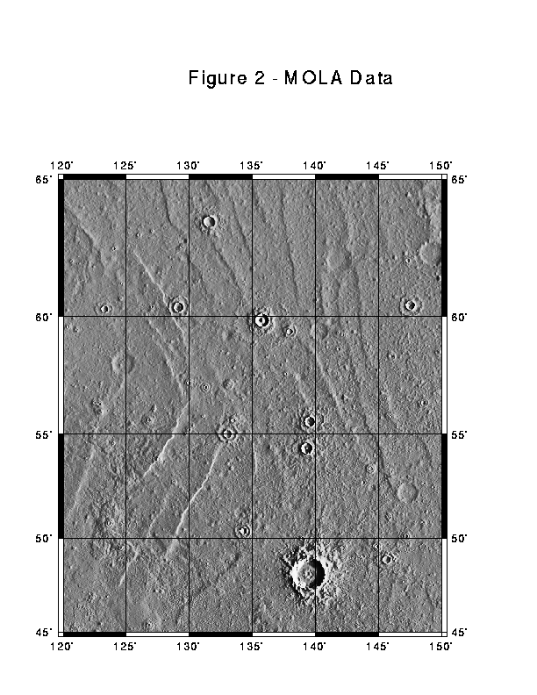
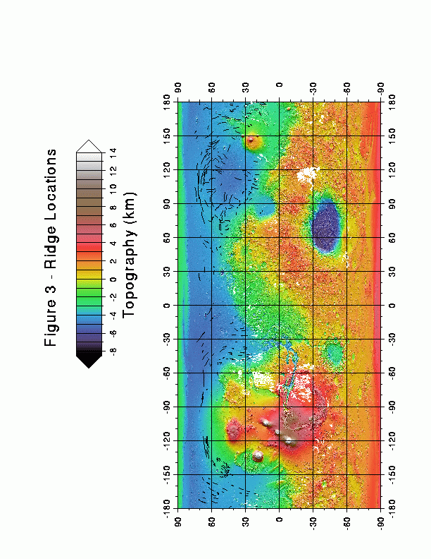

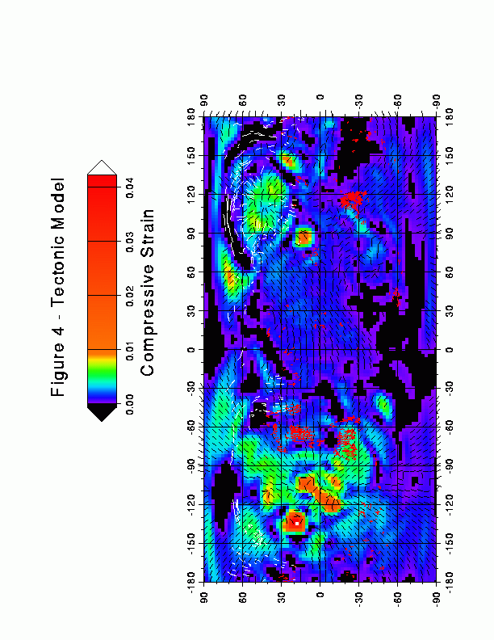

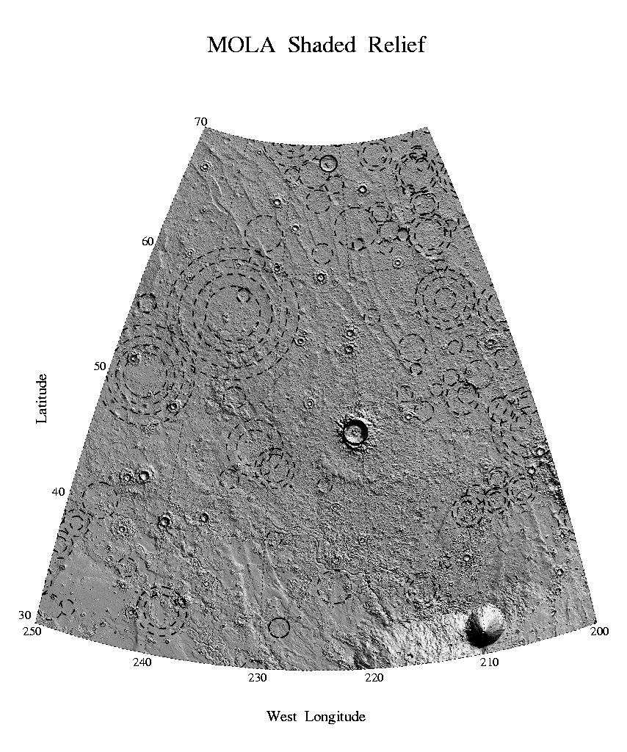

Figure 5 – QCDs overlain on a shaded relief map
Figure prepared by Jim Roark
Access to Frey’s QCD dataset

Message-Id: <4.2.0.58.20010809084052.00b9a5d0@pop3.norton.antivirus>
X-Sender: frey/core2.gsfc.nasa.gov@pop3.norton.antivirus
X-Mailer: QUALCOMM Windows Eudora Pro Version 4.2.0.58
Date: Thu, 09 Aug 2001 09:03:24 -0100
To: withers@LPL.Arizona.EDU
From: Herb Frey <frey@core2.gsfc.nasa.gov>
Subject: Fwd: Images for Paul Withers
Mime-Version: 1.0
Content-Type: multipart/mixed;
boundary="=====================_2443253==_"
Content-Length: 747001
Parts/attachments:
1 Shown 64 lines Text
2 300 KB Image
3 451 KB Image
4 Shown 11 lines Text
----------------------------------------

Paul:
Attached are two GIF versions of the figure you requested, showing QCDs from our preliminary northern lowlands survey superimposed on a shaded relief version of the MOLA topography. Jim roark prepared this figure, and you might acknowledge him as well as reference us. The QCDs can be referenced to our submitted paper:

Frey, H.V., J. H. Roark, K.M. Shockey, E.L. Frey and S.E.H.
Sakimoto , Ancient Lowlands on Mars, submitted to GRL, July 2001.

A couple of important points:
(1) [TEXT DELETED]
(2) Ability to find QCDs depends on the current MOLA grid being used. These were from the 64x32 which is not yet officially released. So this is really a "private communication". You are NOT using the 64x32 gridded data (which you are not yet "allowed" to use until it is in the public domain). You are using a product derived from that by a MOLA team member who is a collaborator and who has agreed to provide the derived product (not the data). This is important because MDAP proposals that indicate use of non-released data are in violation of the requirement of the NRA, and such proposals have been rejected in past panel reviews for that reason. YOU MUST EMPHASIZE THAT THE WORK YOU DO WITH MOLA DATA WILL BE DONE WITH RELEASED MOLA DATA ONLY.
(3) [TEXT DELETED]

[TEXT DELETED]

Have a good one today.
--Herb

Abridged email from Herb Frey. The “derived product” that will be provided is the QCD dataset. It was later agreed that it was not necessary for Frey to be a collaborator.

References

Aharonson, O. et al. (1998) Mars: Northern hemisphere slopes and slope distributions Geophys. Res. Lett., 25, 4413-4416

Banerdt W. B. et al. (1982) Thick Shell Tectonics on One-Plate Planets: Applications to Mars, J. Geophys. Res., 87, 9723-9733

Banerdt W. B. (1986) Support of Long-Wavelength Loads on Venus and Implications for Internal Structure, J. Geophys. Res., 91, 403-419

Banerdt W. B. et al. (1992) Stress and Tectonics on Mars, in Mars, eds. Kieffer H. H. et al., University of Arizona Press, Tucson, AZ

Bilotti F. and Suppe J. (1999) The global distribution of wrinkle ridges on Venus, Icarus, 139, 137-159

Chicarro A. F. et al. (1985) Global and Regional Ridge Patterns on Mars, Icarus, 63, 153-174

COMPLEX (1994) An Integrated Strategy for the Planetary Sciences: 1995-2010, National Academy of Sciences, Washington, DC

Frey H. V. et al. (2000) A Large Population of Possible Buried Impact Basins on Mars Revealed by MOLA Topographic Data, Proc. Lunar Planet. Sci. Conf., 31, #1736.

Frey H. V. et al. (2001a) Buried Impact Basins in the Northern Lowlands of Mars: Implications for Crustal Evolution and the Crustal Dichotomy, Eos Trans. AGU, 82(20), Spring Meet. Suppl., Abstract P31A-04.

Frey H. V. et al. (2001b) A Very Large Population of Likely Buried Impact Basins in the Northern Lowlands of Mars Revealed by MOLA Data, Proc. Lunar Planet. Sci. Conf., 32, #1680.

Frey H. V. et al. (2001c) Ancient Lowlands on Mars, submitted to Geophys. Res. Lett., 2001.

Garvin J. B. and Frawley J. J. (1998) Geometric properties of Martian impact craters: Preliminary results from the Mars Orbiter Laser Altimeter, Geophys. Res. Lett., 25, 4405-4408.

Garvin J. B. et al. (1999) Global Geometric Characteristics of Fresh Impact Craters on Mars: A New Perspective from the Mars Orbiter Laser Altimeter (MOLA), Meteoritics and Planetary Science, 34, Supplement, A41

Garvin J. B. et al. (2000) Global Geometric Properties of Martian Impact Craters: An Assessment from Mars Orbiter Laser Altimeter (MOLA) Digital Elevation Models, Proc. Lunar Planet. Sci. Conf., 31, #1619.

Golombek M. P. et al. (1991) Faulting and folding in the formation of planetary wrinkle ridges, Proc. Lunar Planet. Sci. Conf., 21, 679-693

Golombek M. P. et al. (2001) Martian wrinkle ridge topography: Evidence for subsurface faults from MOLA, J. Geophys. Res., submitted.

Grimm R. E. and Solomon S. C. (1986) Tectonic tests of proposed polar wander paths for Mars and the Moon, Icarus, 65, 110-121

Head J. W. et al. (1999) Possible Ancient Oceans on Mars: Evidence from Mars Orbiter Laser Altimeter Data, Science, 286, 2134-2137

Head J. W. et al. (2001a) Northern Lowlands on Mars: Evidence for Widespread Volcanic Flooding and Tectonic Deformation in the Early Hesperian, Proc. Lunar Planet. Sci. Conf., 32, #1063.

Head J. W. et al. (2001b) Water in Middle Mars History: New Insights From MOLA Data, Eos Trans. AGU, 82(20), Spring Meet. Suppl., Abstract P31A-02.

Head J. W. et al. (2001c) Northern Lowlands on Mars: Evidence for Widespread Volcanic Flooding and Tectonic Deformation in the Hesperian Period, J. Geophys. Res., submitted.

Kreslavsky M. A. and Basilevsky A. T. (1998) Morphometry of wrinkle ridges on Venus: Comparison with other planets, J. Geophys. Res., 103, 11103-11111

Kreslavsky M. A. and Head J. W. (2001a) Stealth Craters in the Northern Lowlands of Mars: Evidence for a Buried Early Hesperian Unit, Proc. Lunar Planet. Sci. Conf., 32, #1001.

Kreslavsky M. A. and Head J. W. (2001b) The Fate of Outflow Channel Effluents in the Northern Lowlands of Mars: The Vastitas Borealis Formation, Eos Trans. AGU, 82(20), Spring Meet. Suppl., Abstract P31A-03.

Lucchitta B. K. (1976) Mare ridges and related highland scarps: Results of vertical tectonism?, Proc. Lunar Planet. Sci. Conf., 7, 2761-2782

Lucchitta B. K. (1977) Topography, structure, and mare ridges in southern Mare Imbrium and northern Oceanus Procellarum, Proc. Lunar Planet. Sci. Conf., 8, 2691-2703

Malin M. C. and Edgett K. S. (1999) Oceans or seas in the martian northern lowlands: High resolution imaging tests of proposed coastlines, Geophys. Res. Lett., 26, 3049-3052

Melosh H. J. (1980) Tectonic patterns on a reoriented planet: Mars, Icarus, 44, 745-751

Melosh H. J. and Raefsky A. (1980) The dynamical origin of subduction zone topography, Geophys. J. Roy. Astron. Soc., 60, 333-354

Melosh H. J. and Raefsky A. (1981) A simple and efficient method for introducing faults into finite-element computations, Bull. Seismol. Soc. Am., 71, 1391-1400

Melosh H. J. and Williams C. A. (1989) Mechanics of graben formation in crustal rocks: A finite-element analysis, J. Geophys. Res., 94, 13961-13973

Melosh H. J. (1989) Impact Cratering, Oxford University Press, New York, NY

Montési, L. G. J., and Zuber, M.T. (2000) The lithospheric structure of the
margin of Tharsis as indicated by wrinkle ridges, Tharsis - Evolution
in light of MGS data, USGS workshop, Flagstaff, Arizona, USA, October 2000.

Montési, L. G. J., and Zuber, M.T. (2001) Crustal Thickness Control on Martian Wrinkle Ridge Spacing, Proc. Lunar Planet. Sci. Conf., 32, #1879.

Office of Space Science (1997) Space Science Enterprise Strategic Plan, NASA, Washington, DC

Phillips R. J. et al. (2001) Ancient Geodynamics and Global-Scale Hydrology on Mars, Science, 291, 2587-2591.

Plescia J. B. and Golombek M. P. (1986) Origin of planetary wrinkle ridges based on terrestrial analogs, Geol. Soc. Am. Bull., 97, 1289-1299

Plescia J. B. (1991) Wrinkle ridges in Lunae Planum, Mars: Implications for shortening and strain, Geophys. Res. Lett., 18, 913-916

Plescia J. B. (1993) Wrinkle ridges of Arcadia Planitia, Mars, J. Geophys. Res., 98, 15049-15059

Schubert G. et al. (1992) Origin and thermal evolution of Mars, in Mars, eds. Kieffer H. H. et al., University of Arizona Press, Tucson, AZ

Schultz P. H. and Lutz A. B. (1988) Polar wandering of Mars, Icarus, 73, 91-141

Schultz R. A. and Tanaka K. L. (1994) Lithospheric-scale buckling and thrust structures on Mars: The Coprates rise and south Tharsis ridge belt, J. Geophys. Res., 99, 8371-8385

Schultz R. A. (2000) Localization of bedding plane slip and backthrust faults above blind thrust faults: Keys to wrinkle ridge structure, J. Geophys. Res., 105, 12035-12052

Sharpton V. L. and Head J. W. III (1988) Lunar mare ridges: Analysis of ridge-crater intersections and implications for the tectonic origin of mare ridges, Proc. Lunar Planet. Sci. Conf., 18, 307-317

Smith D. E. et al. (1998) Topography of the Northern Hemisphere of Mars from the Mars Orbiter Laser Altimeter, Science, 279, 1686-1692

Smith D. E. et al. (1999) The Global Topography of Mars and Implications for Surface Evolution, Science, 284, 1495-1503

Strom R. G. et al. (1975) Tectonism and volcanism on Mercury, J. Geophys. Res., 80, 2478-2507

Tanaka K. L. et al. (1991) Reconciliation of stress and structural histories of the Tharsis region of Mars, J. Geophys. Res.,96, 15617-15633

Watters T. R. (1988) Wrinkle ridge assemblages on the terrestrial planets, J. Geophys. Res., 93, 10236-10254

Watters T. R. (1992) A system of tectonic features common to Earth, Mars, and Venus, Geology, 20, 609-612

Watters T. R. (1993) Compressional tectonism on Mars, J. Geophys. Res., 98, 17049-17060

Watters T. R. and Robinson M. S. (1997) Radar and photoclinometric studies of wrinkle ridges on Mars, J. Geophys. Res., 102, 10889-10903

Wilkins S. J. et al. (2001) Modeling Scarp Evolution: Potential to Date Faulting and Paleoshorelines on Mars, Proc. Lunar Planet. Sci. Conf., 32, #1254.

Wilhelms D. E. and Squyres S. W. (1984) The Martian hemispheric dichotomy may be due to a giant impact, Nature, 309, 138-140

Withers P. and Neumann G. A. (2000) Shallow Ridges in the Martian Northern Plains, Eos Trans. AGU, 81, F780

Withers P. and Neumann G. A. (2001a) Engimatic Northern Plains of Mars, Nature, 410, 651.

Withers P. and Neumann G. A. (2001b) Tectonism in the Northern Plains of Mars, presentation at 33rd Brown-Vernadsky Microsymposium, Houston, Texas, USA.

Zuber M. T. and Aist L. L. (1990) The Shallow Structure of the Martian Lithosphere in the Vicinity of the Ridged Plains, J. Geophys. Res., 95, 14215-14230

Zuber et al. (2000) Internal Structure and Early Thermal Evolution of Mars from Mars Global Surveyor Topography and Gravity, Science, 287, 1788-1793

Facilities and Equipment

Existing facilities and equipment at the University of Arizona, the Jet Propulsion Laboratory, and the Goddard Space Flight Center will be used to perform this proposed research.
Curriculum Vitae – Principal Investigator Melosh

H. Jay Melosh is a Professor of Planetary Science in the Lunar and Planetary Laboratory of the University of Arizona. He is a specialist in the physics of impact cratering on both the Earth, other planets and on small bodies such as comets and asteroids. He and his students have developed computer codes to accurately simulate cratering events both in the laboratory and on small bodies where fracture plays an important role in the cratering process. He developed ideas on how the Martian and lunar meteorites survived ejection at high speed while suffering little shock damage and speculated on the possibility of interplanetary panspermia as a result of the ejection of living organisms. Other work involved study of the orbital evolution of impact ejecta and its ultimate fate. Melosh has also been active in the study of the effects of large impacts on the Earth’s biosphere. Author of a well-received monograph on impact cratering, Melosh has considerable experience with theoretical study of the impact process.

BORN: June 23, 1947, Paterson, New Jersey
ATTENDED: Princeton University, 1965-1969, A.B. (physics) magna cum laude
Caltech 1969-1972, Ph.D. (physics and geology)

Academic Experience
Graduate Teaching Assistant, Caltech, 1969-1971
Visiting Scientist, CERN (Geneva, Switzerland), 1971-1972
Research Associate, University of Chicago, Enrico Fermi Institute,
1972-1973
Instructor in Geophysics and Planetary Science, Caltech, 1973-1975
Assistant Professor of Planetary Science, Caltech, 1976-1978
Associate Professor of Planetary Science, Caltech, 1978-1979
Associate Professor of Geophysics, SUNY, Stony Brook, 1979-1982
Associate Professor of Planetary Science, Univ. of Arizona, 1982-1985
Professor of Planetary Science, Univ. of Arizona, 1985-present

Fellowships and Honors:
Phi Beta Kappa
Sigma Xi
NSF Fellowship, 1969-1972
Best Scientific Secretary Prize, Int'l Summer School of Theoretical
Physics, Erice,Sicily, 1972
Fellow of the Meteoritical Society (July, 1988)
Fellow of the Geological Society of America (November, 1988)
Fellow of the American Geophysical Union (January 1993)
Paul Simon Guggenheim Fellow, 1996-1997.

Recent National and International Committees and Panels
Member, Origin of Sedimentary Basin Task Force, International Lithosphere Program, French Petroleum Institute, Malmaison, France
Scientific Observer, European Science Foundation, Network on "The role of impact processes in the geological and biological evolution of planet Earth". 1993-1996.
Editorial Committee, Annual Reviews of Earth and Planetary Science, 1997-2002.

Abbreviated BIBLIOGRAPHY

CLOETINGH, S., SASSI, W, and TASK FORCE TEAM (including H. J. MELOSH and 19 others), (1994) The origin of sedimentary basins: A status report from the task force of the International Lithosphere Program, Marine and Petroleum Geology 11, 659-683.
DONES, L., GLADMAN, B., MELOSH, H. J., TONKS, W. B., LEVINSON, H. F., DUNCAN, M. (1999) Dynamical lifetimes and final fates of small bodies: Orbit integrations vs. Öpik calculations, Icarus., 142, 509-524.
FREED, A. M., MELOSH, H. J., and SOLOMON, S. C. (2000) Tectonics of mascon loading: Resolution of the strike-slip fault paradox, submitted to Icarus.
HORSTMAN, K.C. and MELOSH, H.J. (1989) Drainage pits in cohesionless materials: Implications for the surface of Phobos. J. Geophys. Res., 94, 12,433-12,441.
JANES, D. and MELOSH, H.J. (1988) Sinker Tectonics: An approach to the surface of Miranda. J. Geophys. Res. 93,3127-3143.
JANES, D. M. and MELOSH, H. J. (1990) Tectonics of planetary loading: A general model and results, J. Geophys. Res., 95, 21,345-21,356.
McKINNON, W.B. and MELOSH, H.J. (1980) Evolution of planetary lithospheres: Evidence from multiringed basins on Ganymede and Callisto. Icarus 44, 454-471.
MELOSH, H.J. (1977) Global tectonics of a despun planet. Icarus 31, 221-243.
MELOSH, H.J. (1977) Shear stress on the base of a lithospheric plate. Pure and Applied Geophys. 115, 429-439.
MELOSH, H.J. (1980) Tectonic patterns on a tidally distorted planet. Icarus 43, 334-337.
MELOSH, H.J. (1980) Tectonic patterns on a reoriented planet: Mars. Icarus 44, 745-751.
MELOSH, H.J. (1981) Atmospheric breakup of terrestrial impactors. In Multi-ring Basins (eds. P.H. Schultz and R.B. Merrill), pp. 29-35, Pergamon.
MELOSH, H.J. (1984) Impact ejection, spallation, and the origin of meteorites. Icarus 59, 234-260.
MELOSH, H.J. (1985) Ejection of rock fragments from planetary bodies. Geology 13, 144-148.
MELOSH, H.J. (1987) High-Velocity solid ejecta fragments from Hypervelocity Impacts. Int. J. Impact Engng. 5, 483-492.
MELOSH, H.J. and DZURISIN, D. (1978) Mercurian tectonics: A consequence of tidal despinning? Icarus 35, 227-236.
MELOSH, H.J. and DZURISIN, D. (1978) Tectonic implications for the gravity structure of Caloris basin, Mercury. Icarus 33, 141-144.
MELOSH, H. J. and IVANOV, B. A. (1999) Impact crater collapse. Ann. Rev. Earth Planet. Sci. 27, 385-415.
MELOSH, H.J. and RAEFSKY, A. (1981) A simple and efficient method for introducing faults into finite element computations. Bull. Seis. Soc. Am. 71, 1391-1400.
MELOSH, H.J. and RAEFSKY, A. (1983) Anelastic response of the earth to a dip-slip earthquake. J. Geophys. Res. 88, 515-526.
MELOSH, H. J., RYAN, E. A., and ASPHAUG, E. (1992) Dynamic fragmentation in impacts: Hydrocode simulation of laboratory impacts, J. Geophys. Res. 97, 14,735-14,759.
MELOSH, H. J. and RYAN, E. V. (1997) Asteroids: Shattered but not dispersed, Icarus, 129, 562-564.
MORGAN, J. V., WARNER, M. R., COLLINS, G. S., MELOSH, H. J. and CHRISTENSON, G. L. (2000) Peak ring formation in large impact craters, EPSL, 183, 347-354.
PASSEY, Q. and MELOSH, H.J. (1980) The effects of atmospheric breakup on crater field formation. Icarus 42, 211-233.
PIERAZZO, E. and MELOSH, H. J. (2000) Melt production in oblique impacts, Icarus 145, 252-261.
PIERAZZO, E. and MELOSH, H. J. (2000) Hydrocode modeling of oblique impacts: The fate of the projectile. Meteoritics Planet. Sci., 35, 117-130.
PIERAZZO, E. and MELOSH, H. J. (2000) Understanding oblique impacts from experiments, observations and modeling. Ann. Rev. Earth and Planet. Sci., 28, 141-167.
RYAN, E. V. and MELOSH, H. J. (1998) Impact fragmentation: From the laboratory to asteroids, Icarus, 133, 1-24.
VILOTTE, J. P., MELOSH, H. J., SASSI, J., and RANALLI, G. (1993) Lithosphere rheology and sedimentary basins, Tectonophysics, 226, 89-95.
WALLACE, M. and MELOSH, H. J. (1994) Buckling of a pervasively faulted lithosphere, PAGEOPH, 142, 239-261
WANG, K., DRAGERT, H. and MELOSH, H. J. (1994) Finite element study of uplift and strain across Vancouver Island, Can. J. Earth Sci.31, 1510-1522.

BOOKS
MELOSH, H.J. (1989) Impact Cratering: A Geologic Process. Oxford University Press, 245 pp.
MELOSH, H. J. (1997) Origins of Planets and Life, Ann. Rev. Inc., Palo Alto, CA.

Curriculum Vitae – Co-Investigator Withers

Third year PhD candidate and Graduate Research Associate,
Lunar and Planetary Laboratory, University of Arizona.

Summer research placements at:

Beagle 2 group at the Open University, Great Britain, summer 2001
MOLA group at NASA/GSFC, summer 2000
Theoretical Astrophysics Program at Caltech, summer 1997
Isaac Newton Group of Telescopes on La Palma, Spain, summer 1996

Academic Status:

Completed required courses at University of Arizona, all grades A.
GRE Physics, 92nd percentile, and GRE General, 97th percentile or better in all subjects.
BA and MS in Physics, University of Cambridge, all grades equivalent of A.

Bibliography:

Withers P. (2001) Meteor Storm Evidence Against the Recent Formation of Lunar Crater Giordano Bruno, Meteoritics, 36, 525-529
Withers P. and Neumann G. A. (2000) Shallow Ridges in the Martian Northern Plains, Eos Trans. AGU, 81, F780
Withers P. and Neumann G. A. (2001a) Tectonism in the Northern Plains of Mars, Nature, 410, 651
Withers P. and Neumann G. A. (2001b) Tectonism in the Northern Plains of Mars, presentation at 33rd Brown-Vernadsky Microsymposium, Houston, Texas, USA.
Lorenz R. D., Lunine J. I., Withers P., and McKay C. P. (2001) Titan, Mars, and Earth: Entropy Production by Latitudinal Heat Transport, Geophys. Res. Lett., 28, 415-418

Work on MGS accelerometer measurements of upper atmospheric density during aerobraking has so far led to lead authorship of several conference presentations and coauthorship of a paper submitted to Geophys. Res. Lett.

Highly Commended –Young Science Writer of the Year contest, 2000, offered by The Daily Telegraph, a British national newspaper
Winner – NASA’s Deep Space 2 naming contest, out of 17,000 entrants

Professional Organisations:

Member of AGU’s Planetary Sciences Section and AAS’s Division of Planetary Sciences

Current and Pending Support

Principal Investigator Melosh

Current Support:
Deep Impact
NASA Discovery Mission
David Jarrett, Discovery Program Manager, JPL (David.B.Jarrett@jpl.nasa.gov)
01 June 2000 – 31 May 2006, annual funding to Melosh of ca. $30K
0.10 of a full time Work Year during this period

Verification of computer models of impact cratering with geological data
US Cooperative Grants Program
US Civilian Research and Development Foundation (Cpg@crdf.org)
01 May 2000 – 31 October 2001, total funding to Melosh of $8K
0.02 of a full time Work Year during this period

Pending Support:
Impact cratering and the evolution of the terrestrial planets
NASA NAG5-6543
Tracey Jones, Grant Specialist, GSFC (Tracey.A.Jones@gsfc.nasa.gov)
01 October 2000 – 31 September 2001, total funding to Melosh of $165K
0.25 of a full time Work Year during this period

Co-Investigator Withers

Current Support:
Research Associate to S. W. Bougher
Lunar and Planetary Laboratory, University of Arizona
Lynn Lane, Business Manager (lynn@lpl.arizona.edu)
Fall Semester, 2001, total funding to Withers of $8K
0.5 of a full time position during this period

Pending Support:
No pending support at this time
Statement of Commitment - Withers

Received: (from withers@localhost)
by LPL.Arizona.EDU (8.10.2+Sun/8.9.1) id f72ATht00786;
Thu, 2 Aug 2001 03:29:43 -0700 (MST)
Date: Thu, 2 Aug 2001 03:29:42 -0700 (MST)
From: Paul Withers <withers@LPL.Arizona.EDU>
X-Sender: withers@hindmost
To: Paul Withers <withers@LPL.Arizona.EDU>
Subject: Letter of Acknowledgement (fwd)
Message-ID: <Pine.SUN.3.90.1010802032916.718G-100000@hindmost>
MIME-Version: 1.0
Content-Type: TEXT/PLAIN; charset=US-ASCII
Content-Length: 517

Dear Dr. Melosh,

I acknowledge that I am identified by name as Collaborator to the
investigation, entitled "Tectonism in the northern plains of Mars", that
is submitted by H.J. Melosh to the NASA Research Announcement ROSS-2001,
and that I intend to carry out all responsibilities identified for me in
this proposal. I understand that the extent and justification of my
participation as stated in this proposal will be considered during peer
review in determining the merits of this proposal.

signed,

Paul Withers

Statement of Commitment - Banerdt

Received: from eis-msg-012.jpl.nasa.gov (eis-msg-012.jpl.nasa.gov
[137.78.160.40])
by LPL.Arizona.EDU (8.10.2+Sun/8.9.1) with ESMTP id f721UvZ06195
for <withers@lpl.arizona.edu>; Wed, 1 Aug 2001 18:30:57 -0700 (MST)
Received: from [137.79.19.39] (geofizix-jr.jpl.nasa.gov [137.79.19.39])
by eis-msg-012.jpl.nasa.gov (8.9.3/8.9.3) with ESMTP id SAA28404
for <withers%lpl.arizona.edu@smtp.jpl.nasa.gov>; Wed, 1 Aug 2001
18:31:20 -0700 (PDT)
Mime-Version: 1.0
X-Sender: bbanerdt@pop.jpl.nasa.gov
Message-Id: <p04330102b78e6c1e6447@[137.79.19.39]>
In-Reply-To: <Pine.SUN.3.90.1010730081520.9230F-100000@hindmost>
References: <Pine.SUN.3.90.1010730081520.9230F-100000@hindmost>
Date: Wed, 1 Aug 2001 18:33:27 -0800
To: Paul Withers <withers@lpl.arizona.edu>
From: "W. Bruce Banerdt" <bruce.banerdt@jpl.nasa.gov>
Subject: Letter of Acknowledgement
Content-Type: text/plain; charset="us-ascii" ; format="flowed"
Content-Length: 827
Dear Dr. Melosh,

I acknowledge that I am identified by name as Collaborator to the
investigation, entitled "Tectonism in the northern plains of Mars", that
is submitted by H.J. Melosh to the NASA Research Announcement ROSS-2001,
and that I intend to carry out all responsibilities identified for me in
this proposal. I understand that the extent and justification of my
participation as stated in this proposal will be considered during peer
review in determining the merits of this proposal.

signed,

W.Bruce Banerdt
--
***********************************************************************

W. Bruce Banerdt bruce.banerdt@jpl.nasa.gov

Mail Stop 183-501 Tel: (818) 354-5413
Jet Propulsion Laboratory
4800 Oak Grove Drive Fax: (818) 393-9226
Pasadena, CA 91109

Statement of Commitment - Neumann

Received: from tharsis.gsfc.nasa.gov (tharsis.gsfc.nasa.gov [128.183.105.20]) by LPL.Arizona.EDU (8.10.2+Sun/8.9.1) with ESMTP id f6UKG8Z17975 for <withers@LPL.Arizona.EDU>; Mon, 30 Jul 2001 13:16:08 -0700 (MST)
Received: (from neumann@localhost) by tharsis.gsfc.nasa.gov (8.9.3/8.9.3) id QAA05468 for withers@LPL.Arizona.EDU; Mon, 30 Jul 2001 16:16:14 -0400 (EDT)
Date: Mon, 30 Jul 2001 16:16:14 -0400 (EDT)
From: Greg Neumann <neumann@tharsis.gsfc.nasa.gov>
Message-Id: <200107302016.QAA05468@tharsis.gsfc.nasa.gov>
To: withers@LPL.Arizona.EDU
Subject: Re: MDAP proposal
Content-Type: X-sun-attachment
Content-Length: 29924
----------
X-Sun-Data-Type: default
X-Sun-Data-Description: default
X-Sun-Data-Name: collabaz.doc
X-Sun-Encoding-Info: uuencode
X-Sun-Content-Lines: 459

begin 600 collabaz.doc
Lunar and Planetary Laboratory
University of Arizona
Tucson, AZ 85721

NASA-Goddard Space Flight Center
Code 920
Greenbelt, MD 20771
Lab: 301 614 6026
Fax: 301 614 6015

Dear H.J. Melosh,

I acknowledge that I am identified by name as Collaborator to the investigation entitled "Tectonism in the northern plains of Mars " that is being submitted by H.J. Melosh to the NASA Reseach Announcement ROSS-2001, and that I intend to carry out all responsibilities identified for me in this proposal. I understand that the extent and justification of my participation as stated in this proposal will be considered during peer review in determining the merits of this proposal.

Sincerely,

Gregory A. Neumann
Research Scientist
Dept. of Earth, Atmospheric, and Planetary Sciences
Massachusetts Institute of Technology
also at NASA-GSFC Laboratory for Terrestrial Physics

BUDGET SUMMARY for Research Proposal

For (check one):
Total Period of Performance from (M/D/YY) 3/20/02 to 3/20/04
For Year of from (M/D/YY) to

NASA USE ONLY

A B C
1. Direct Labor (salaries, wages and
fringe benefits) $22,482 _________ _________
2. Other Direct Costs:
a. Subcontracts _________ _________

b. Consultants _________ _________
c. Equipment _________ _________

d. Supplies $1,400 _________ _________

e. Travel $5,600 _________ _________

f. Other _________ _________

3. Facilities and Administrative Costs $15,184 _________ _________

4. Other Applicable Costs: _________ _________

5. SUBTOTAL--Estimated Costs $44,666 _________ _________

6. Less Proposed Cost Sharing (if any) _________ _________

7. Carryover Funds (if any)
a. Anticipated amount:
b. Amount used to reduce budget _________ _________

8. Total Estimated Costs $44,666 _________ XXXXXX

9. APPROVED BUDGET XXXXXX XXXXXX _________
BUDGET SUMMARY for Research Proposal

For (check one):
Total Period of Performance from (M/D/YY) to
For Year 1 of 2 from (M/D/YY) 3/20/02 to 3/20/03

NASA USE ONLY

A B C
1. Direct Labor (salaries, wages and
fringe benefits) $11,241 _________ _________
2. Other Direct Costs:
a. Subcontracts _________ _________

b. Consultants _________ _________
c. Equipment _________ _________

d. Supplies $700 _________ _________

e. Travel $2,800 _________ _________

f. Other _________ _________

3. Facilities and Administrative Costs $7,592 _________ _________

4. Other Applicable Costs: _________ _________

5. SUBTOTAL--Estimated Costs $22,333 _________ _________

6. Less Proposed Cost Sharing (if any) _________ _________

7. Carryover Funds (if any)
a. Anticipated amount:
b. Amount used to reduce budget _________ _________

8. Total Estimated Costs $22,333 _________ XXXXXX

9. APPROVED BUDGET XXXXXX XXXXXX _________
BUDGET SUMMARY for Research Proposal

For (check one):
Total Period of Performance from (M/D/YY) to
For Year 2 of 2 from (M/D/YY) 3/20/03 to 3/20/04

NASA USE ONLY

A B C
1. Direct Labor (salaries, wages and
fringe benefits) $11,241 _________ _________
2. Other Direct Costs:
a. Subcontracts _________ _________

b. Consultants _________ _________
c. Equipment _________ _________

d. Supplies $700 _________ _________

e. Travel $2,800 _________ _________

f. Other _________ _________

3. Facilities and Administrative Costs $7,592 _________ _________

4. Other Applicable Costs: _________ _________

5. SUBTOTAL--Estimated Costs $22,333 _________ _________

6. Less Proposed Cost Sharing (if any) _________ _________

7. Carryover Funds (if any)
a. Anticipated amount:
b. Amount used to reduce budget _________ _________

8. Total Estimated Costs $22,333 _________ XXXXXX

9. APPROVED BUDGET XXXXXX XXXXXX _________
Budget Details

Calculated for 2 years, complete duration of proposal. Annual costs are identical for each year, i.e. half of those listed here.

1. Salaries and Wages $ 21617
(Co-Investigator Withers, 6 months per year)

2. Benefits $ 865
(Graduate Associates 4%)

3. Supplies $ 1400
Publication charges $600
FedEx $200
Telephone and fax $200
Office supplies $100
Photocopying $100
Computing supplies $100
Miscellaneous $100

4. Travel $ 5600
Withers attends 2 scientific meetings of
7 days each in the continental US per year.
Estimated cost per meeting is $1400
airfare $500
accommodation $500
per diem $250
registration $100
ground transportation $ 50

5. Total Direct Cost $ 29482

6. Total Indirect Cost $ 15184
(51.5% overhead)

7. Total Cost $ 44666
(for two-year
duration of proposal)

ANNUAL COST - $ 22333

