Table of Contents

Cover Page

Summary of Personnel, Commitments, and Costs 2

Scientific/Technical/Management Section 3

Objectives and Significance of Proposed Research 3

Impact of Proposed Research 4

Technical Approach and Methodology 7

Relevance of Proposed Research 9

Outline of Plan of Work 11

Expected Contributions 12

Figures 13

References 17

Facilities and Equipment 20

Curriculum Vitae – Principal Investigator 21

Curriculum Vitae – Co-Investigator 24

Current and Pending Support 25

Statements of Commitment 26

Research Budget Summary and Details 29

Reprints 33

Summary of Personnel, Commitments, and Costs

Name Role Time Commitment Unburdened Salary
(fraction of a work year) (per year)

H. J. Melosh PI 0.05 $ 0
P. Withers Co-I and Science PI 0.5 $ 12000

Collaborators: W. B. Banerdt and G. A. Neumann

Commitments are identical for all years of the proposed research.

Professor Melosh’s time commitment, valued at approximately $4000 per year, will be supported by his academic position at the University of Arizona. This will reduce the cost to NASA of this grant proposal.

Scientific/Technical/Management Section

Objectives and Significance of Proposed Research

Basic objective - Continue our investigations of tectonic ridges in the northern plains of Mars using MOLA data, theoretical models, and Viking and MOC imagery.

Expected significance – The proposed research will enhance our understanding of the tectonic history of Mars, the origin of the northern plains, and the possibility of an ancient northern ocean.

Task 1 – Map these ridges and their properties. Variations in ridge properties will indicate variations in lithospheric structure or stress regime.

Task 2 – Calculate regional strain magnitudes and directions in the northern plains using the results of Task 1. This will provide a constraint on tectonic models of the northern plains.

Task 3 – Model stress and strain in the northern plains. Adjusting the model parameters to best fit the results of Task 2 will constrain the nature of the lithospheric structure and loading in the vicinity of the northern plains.

Task 4 – Test the ancient northern ocean hypothesis. Examining those of the ridges that are proposed as shoreline candidates to see if they lie on an equipotential, and if they have a tectonic or shoreline process morphology, will either strengthen or weaken the case for an ancient northern ocean.

Task 5 – Examine photographic images of these ridges. Viking and MOC images may reveal fine-scale structure on these ridges, occurrences of which can be correlated with other ridge properties.

Task 6 – Examine depth-diameter relations of a population of subdued craters, visible in MOLA images of the northern plains, which is not seen in Viking images. This will constrain the depositional and erosional history of the northern plains and be used to estimate the extent to which the ridges have undergone modification.

Task 7 – Use a finite-element model to study these ridges. This numerical model will complement the spherical harmonic model of Task 3.

Impact of Proposed Research

Figure 1 shows a Viking photomosaic of the northern part of the Utopia impact basin. Craters are visible on a mottled terrain. Figure 2 shows a digital terrain model generated from gridded MOLA data available from the Planetary Data System (PDS) [Smith et al. 1999]. Many new features are visible, including a second, subdued, population of craters and a network of ridges. This comparison forcibly demonstrates that photographic images do not reveal all of a surface’s secrets. Improved global photomosaics may be forthcoming from the MOC and THEMIS instruments, however, despite improved resolution, they will suffer from the same handicaps as Viking did in imaging these shallow features.

MOLA data reveal that the northern plains of Mars are the flattest known surface in the solar system and that they are criss-crossed by ridges of likely tectonic origin [Smith et al., 1998; Withers and Neumann, 2000, 2001]. High-resolution shaded topographic images of the polar basin, available at http://ltpwww.gsfc.nasa.gov/tharsis/mola.html at km resolution, show the ridges clearly. A global digital terrain model at 1/32º resolution is being released to the PDS in January 2001 and higher resolution models will be publicly available at the start of this study.

The causes of the youth and smoothness of the northern plains are still debated [Smith et al., 1998, and references therein; Zuber et al., 2000]. The network of ridges is the dominant, indeed the only, tectonic feature throughout this enigmatic region, which covers a quarter of the planet. The most complete survey of martian ridges to date, which mapped over 16,000 ridges, commented that “as is well known, the northern plains have few ridges” and was not able to identify the network of ridges revealed by MOLA (Chicarro et al., 1985).

Wrinkle ridges are one of the most commonly observed, yet least understood, classes of planetary structure [e.g. Schultz, 2000; Watters, 1992]. They occur on all the terrestrial planets, including Mercury (e.g. Strom et al., 1975), Venus (e.g. Kreslavsky and Basilevsky, 1998; Bilotti and Suppe, 1999), Earth (e.g. Plescia and Golombek, 1986; Watters, 1988), the Moon (e.g. Lucchitta, 1976, 1977; Sharpton and Head, 1988), and Mars (e.g. Plescia, 1991, 1993; Watters and Robinson, 1997). Observations of martian wrinkle ridges have been used to constrain the planetary thermal history (e.g. Banerdt et al., 1992), tectonic history (e.g. Tanaka et al., 1991; Schultz and Tanaka, 1994), volcanic history (e.g. Watters, 1993), impact history (e.g. Wilhelms and Squyres, 1984; Chicarro et al., 1985), lithospheric structure (e.g. Zuber and Aist, 1990), and changes in orbital and rotational dynamics (e.g. Melosh, 1989; Grimm and Solomon, 1986; Schultz and Lutz, 1988).

Studying this network of ridges will enhance our understanding of the tectonic history of Mars, the origin of the northern plains, and the possibility of an ancient northern ocean. In earlier work, we began to investigate the distribution and nature of these ridges [Withers and Neumann, 2000, 2001]. Maps of absolute surface slope were generated from gridded MOLA topographic data. Ridges stood out as linear regions of greater than background slope and were easily identifiable. Then, in the topographic data, these linear regions were illuminated across-strike and could be confirmed as ridges, rather than troughs or other features. To date, ridge locations have been mapped, ridge properties have begun to be mapped, correlations with predicted strain fields have been noted, and some shoreline candidates have been rejected [Withers and Neumann, 2000, 2001].

The ridges have characteristic wrinkle ridge profiles, characteristic lengths of 100s of kilometers, characteristic heights of 100 metres, and characteristic flank slopes on the order of only 1 degree. Ridge spacings vary throughout the northern plains, but are on the order of 100 km. These spacings are greater than those found on the neighbouring known wrinkle ridge provinces [Zuber and Aist, 1990, and references therein]. More detailed studies of ridge properties will enable these ridges to be compared and contrasted to other wrinkle ridges in the solar system, and let us constrain models for their evolution (Tasks 1, 2, and 5).

The locations of these ridges are shown in Figure 3. Most ridges appear related to obvious stress centers, such as the volcanic Tharsis Rise, the Utopia impact basin, and the Alba Patera volcano. Figure 4 shows a prediction of compressive strain in the martian lithosphere, performed by Banerdt. Almost all of the ridges are orthogonal to the predicted direction of maximum compressive strain, as expected for wrinkle ridges underlain by thrust faulting. An obvious exception is the family of radial ridges within the Utopia impact basin. Previous comparisons of observed and predicted strains on Mars have had no observed strains in the northern plains, or on a quarter of the planet. With our observations of strain in the northern plains, tectonic models can be tested more precisely, which will constrain the lithospheric structure of the northern plains and the nature of the Tharsis loading [Banerdt et al., 1982; Banerdt, 1986; Banerdt et al., 1992; Melosh and Raefsky, 1980, 1981; Melosh and Williams, 1989] (Tasks 2, 3, and 7).

Some of these ridges have been suggested as putative shorelines for an ancient northern ocean by Head et al. [1999]. We examined profiles of several putative shorelines and found their morphology to be inconsistent with an oceanic origin; shorelines on one side of the ocean had terraces downslope from ridges - with the arrangement reversed on the other side of the ocean [Withers and Neumann, 2000, 2001]. Examining more putative shorelines will further test the ancient ocean hypothesis (Task 4).

The northern plains have been modified by deposition since ridge formation. The amount of deposition that has occurred since ridge formation can be estimated by studying depth-diameter relations in a subdued population of craters not visible in Viking images. Allowing for the different geometries of ridges and craters, and, consequently, their different response to erosion and deposition, the extent to which the ridges have been modified since their formation will be estimated. We will also attempt to stratigraphically date ridge formation by analysis of ridge-crater superposition and cross-cutting relationships. This work will also be very useful in constraining the pre-Amazonian history of the northern plains (Task 6).

The main focus of this research proposal is the network of ridges. However, quantitative information on the deposition of materials in the northern plains, provided by the crater studies described above, will have a major impact on the following questions:
Was the most recent major deposition in the northern plains uniform?
Is the size of this deposition consistent with estimates from outflow channel studies?
When did this deposition occur?
Can resurfacing models provide several kilometres of fill (as seen in the Utopia basin) early in martian history, then several hundred metres of fill (as seen in the subdued craters)?
What can be said about the pre-deposition surface?

Perhaps Task 6 and the question of ridge modification is not the most important task for our tectonic studies. We nonetheless recognize its importance for a great many other studies and will not neglect it.

Technical Approach and Methodology

Task 1 – Topographic profiles will be constructed across the ridges using gridded MOLA topographic data publicly available from the PDS, and the height, width, flank slopes, elevation offset, and asymmetry of each ridge will be measured. These results will be used to see if there are any distinct classes of ridges within the northern plains, or if all are morphologically similar. They will then be compared to results from previously studied wrinkle ridge provinces.

Task 2 – Use the methods of Golombek et al. (1991) and the results of Task 1 to estimate shortening across ridges. Then use ridge spacings and orientations to calculate regional strain magnitudes and directions throughout the northern plains.

Task 3 – Use the existing models of Banerdt to predict magnitudes and directions of stress and strain in the northern plains [Banerdt et al., 1982; Banerdt, 1986; Banerdt et al., 1992]. Compare to the results of Task 2. Models with different lithospheric structure and different loading can be tested, and rejected if their predictions are inconsistent with the results of Task 2.

Task 4 – Head et al. (1999) proposed “linear slope changes” in the northern plains as putative shorelines. Ridges are “linear slope changes” and those close to proposed shorelines will be examined using gridded MOLA topographic data to test if they lie along an equipotential, if they have a morphology consistent with formation by shoreline processes, if there is a preferred equipotential for ridges to form along, and if they are clearly distinguishable from ridges of tectonic origin, either in morphology or location. This will complement the studies of Malin and Edgett (1999), who used MOC images to test the ancient ocean hypothesis. There is still debate about what an ancient martian shoreline might look like in an image. However, it must once have lain along an equipotential and almost certainly will not have a topographic profile like that of a wrinkle ridge. Thus, our proposed studies will be minimally affected by this (sometimes acrimonious) debate.

Task 5 – As Figures 1 and 2 show, only a fraction of the ridges in the northern plains are visible in Viking images, and then only if one knows where to look. Viking images of the northern plains will be examined in conjunction with gridded MOLA topographic data, and those ridges that are visible in the Viking images will be studied for any interesting morphological features that are not apparent in the 1 km horizontal resolution MOLA data. High-resolution MOC images, with metre-scale resolution, are available for a fraction of the martian surface. Where these cross the ridges, any interesting morphological features will be noted. MOC images are inappropriate for studying the morphology of an entire ridge and only the fine-scale “wrinkles” of wrinkle ridges are likely to appear in these images. Mechanisms by which fine-scale structure is formed on wrinkle ridges are unclear at present. However, correlating the occurrence of different types of fine-scale structure with other ridge properties may be useful.

Task 6 – The northern plains of Mars are late Hesperian to Amazonian in age, while neighbouring early Hesperian ridged plains are older. The observed continuation of Lunae Planum wrinkle ridges into the northern plains, predicted tectonic histories of Mars, and other evidence, suggests that the ridges in the northern plains also formed in the early Hesperian [Withers and Neumann, 2000; Banerdt et al., 1992]. As the surface of the northern plains is younger than this, surface modification sufficient to partially hide craters, but insufficient to obliterate the wrinkle ridges, must have occurred. Recall the subdued population of craters visible in Figure 2 (MOLA) but not in Figure 1 (Viking). Crater depth-diameter relations are well known, and hence the depth to which material has been deposited on different regions of the northern plains can be estimated [Melosh, 1989]. The observed density of subdued craters will help constrain the age of this buried unit.

Task 7 – The tectonic models of Banerdt (Task 3) incorporate a spherical harmonic representation of the gravity field and topography as boundary conditions to analytically solve for the tectonic state of a planet [Banerdt et al., 1982; Banerdt, 1986; Banerdt et al., 1992]. A complementary tectonic model, based on the numerical method of finite-element analysis, will also be used to study stress and strain in the martian lithosphere [Melosh and Raefsky, 1980, 1981; Melosh and Williams, 1989]. This model is better able to investigate the effects of variations in lithospheric thickness or loading on a small spatial scale.

Relevance of Proposed Research

This proposed research enhances the scientific return of the Mars Global Surveyor mission in the following ways:

A – Discovery and characterization of an unsuspected class of tectonic features on the northern plains, an enigmatic region of near global scale, of Mars.

B – Uses these features to constrain global scale tectonic models, with special emphasis on Tharsis.

C – Tests the ancient northern ocean hypothesis.

D – Constrains the resurfacing history of the northern plains of Mars.

Enhancement C indirectly addresses the issue of extra-terrestrial biology, an issue that thoroughly permeates NASA’s plans and aims.

All these enhancements satisfy the Science Goal of the Space Science Enterprise Strategic Plan of “Understand the nature and history of our Solar System” and the two Science Objectives of “Characterize the history, current environment, and resources of Mars, especially the accessibility of water” and “Investigate the processes that underlie the diversity of solar system objects” [Office of Space Science, 1997].

The National Academy of Sciences’ Committee on Lunar and Planetary Exploration (COMPLEX) has advised NASA on NASA’s plans [COMPLEX, 1994].

It stated a primary objective for understanding planets to be: Specify the nature and sources of stress that are responsible for the global tectonics of Mars. Enhancements A and B address this objective.

It stated another primary objective to be “Advance significantly our understanding of stratigraphic relationships for all solid planets.” Enhancement D addresses this objective.

COMPLEX also posed several key questions for understanding the surfaces and interiors of solid bodies.

It asked: How do global- versus local-scale processes contribute to the observed tectonics? Enhancements A and B address this question.

It asked: How did the Tharsis and Elysium bulges on Mars form, and what do they imply for the state of stress in the crust and the dynamics of the interiors of the planet? Enhancement B addresses this question.

It asked: What are the erosional and sedimentation histories of Mars? Enhancements C and D address this question.

It asked: To what extent have materials been redistributed across their surfaces? Enhancements C and D address this question.
Outline of Plan of Work

First six months

End Task 1 Map ridges Neumann, Withers
End Task 2 Calculate regional strains Neumann, Withers
Start Task 3 Theoretically model tectonics Banerdt

Present results at a scientific meeting
Submit paper covering previous work and results of Tasks 1 and 2

Second six months

Continue Task 3 Theoretically model tectonics Banerdt
Start Task 4 Test ancient northern ocean hypothesis Withers
Start Task 5 Examine Viking and MOC images Withers
Start Task 6 Study subdued population of craters Melosh, Withers

Present results at a scientific meeting and at a MOLA Science Team meeting

Third six months

Continue Task 3 Theoretically model tectonics Banerdt
End Task 4 Test ancient northern ocean hypothesis Withers
Continue Task 5 Examine Viking and MOC images Withers
Continue Task 6 Study subdued population of craters Melosh, Withers
Start Task 7 Finite-element analysis Melosh, Withers

Present results at a scientific meeting
Submit paper covering results of Task 4 and latest results from Tasks 3, 5, and 6

Fourth and final six months

End Task 3 Theoretically model tectonics Banerdt
End Task 5 Examine Viking and MOC images Withers
End Task 6 Study subdued population of craters Melosh, Withers
End Task 7 Finite-element analysis Melosh, Withers

Present results at a scientific meeting and at a MOLA Science Team meeting
Submit paper on final results from this research proposal

Expected Contributions

Melosh (Principal Investigator)

Professor Melosh has studied planetary tectonics for many years. He is an expert on finite-element modelling of tectonic problems and all aspects of impact cratering [Melosh and Raefsky, 1980, 1981; Melosh and Williams, 1989; Melosh, 1989].

• Responsible for quality and direction of research, and for use of awarded funds
• Supervisory role for Withers
• Direct crater analysis for Task 6
• Direct initial finite-element studies for Task 7

Withers (Co-Investigator and Science PI)

Mr. Withers, a PhD student, initiated this project during a summer research placement at NASA’s Goddard Space Flight Center. He presented initial results from that placement at Fall AGU, 2000 [Withers and Neumann, 2000].

• Lead role in proposal preparation
• Responsible for day-to-day progress in most Tasks
• Direct test of ancient northern ocean hypothesis for Task 4
• Direct investigation of Viking and MOC images for Task 5

Banerdt (Collaborator)

Dr. Banerdt, a member of the MOLA Science Team, wrote the standard reference on martian tectonics [Banerdt et al., 1992]. He uses theoretical tectonic models to constrain lithospheric structure and loading on the terrestrial planets [Banerdt et al., 1982; Banerdt, 1986; Banerdt et al., 1992].

• Use theoretical models to predict stress and strain for Task 3

Neumann (Collaborator)

Dr. Neumann, a member of the MOLA Science Team, leads the processing of raw MOLA data into a scientifically useful product. He supervised the summer research placement of Withers and is intimately familiar with the MOLA data.

• Continue to guide Withers through use of large gridded data sets
• Assist in automating the measurement of ridge properties for Tasks 1 and 2
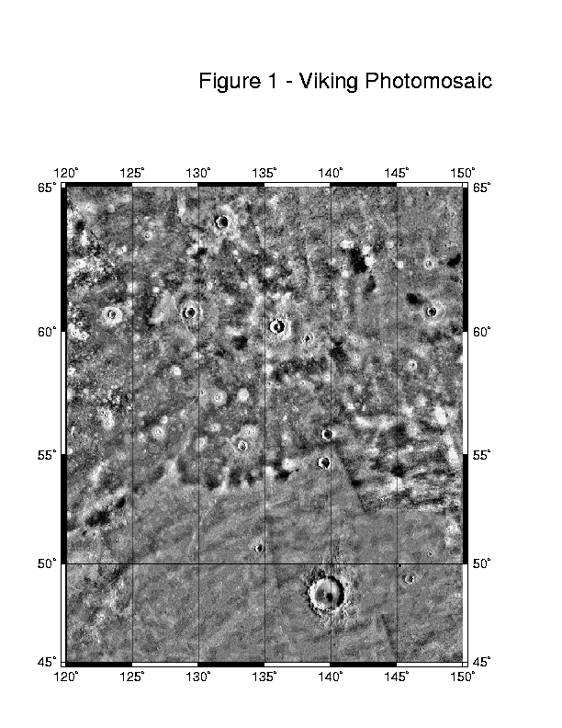
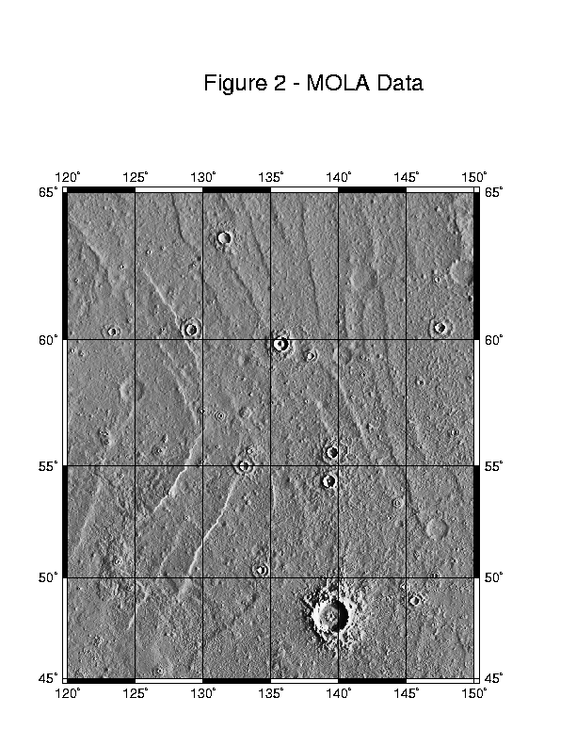
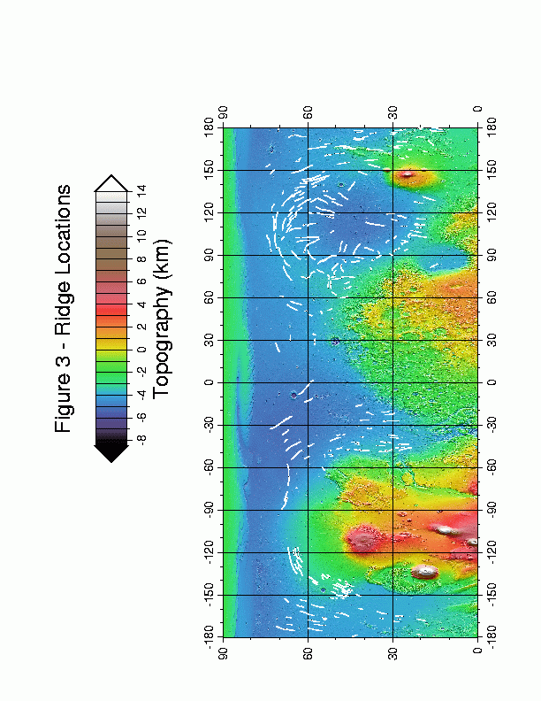
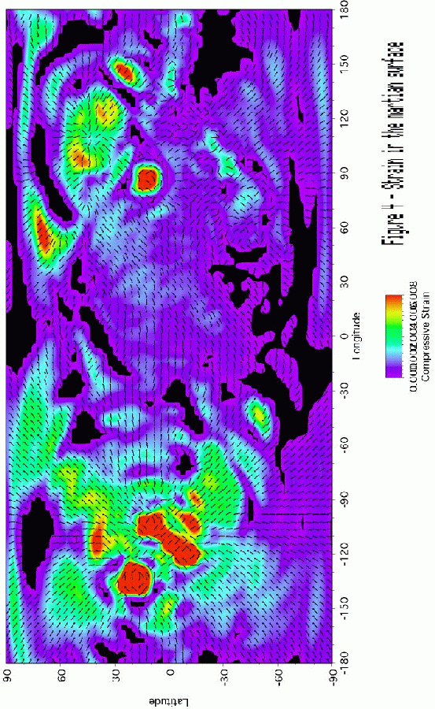

References

Banerdt W. B. et al. (1982) Thick Shell Tectonics on One-Plate Planets: Applications to Mars, J. Geophys. Res., 87, 9723-9733

Banerdt W. B. (1986) Support of Long-Wavelength Loads on Venus and Implications for Internal Structure, J. Geophys. Res., 91, 403-419

Banerdt W. B. et al. (1992) Stress and Tectonics on Mars, in Mars, eds. Kieffer H. H. et al., University of Arizona Press, Tucson, AZ

Bilotti F. and Suppe J. (1999) The global distribution of wrinkle ridges on Venus, Icarus, 139, 137-159

Chicarro A. F. et al. (1985) Global and Regional Ridge Patterns on Mars, Icarus, 63, 153-174

COMPLEX (1994) An Integrated Strategy for the Planetary Sciences: 1995-2010, National Academy of Sciences, Washington, DC

Golombek M. P. et al. (1991) Faulting and folding in the formation of planetary wrinkle ridges, Proc. Lunar Planet. Sci. Conf., 21, 679-693

Grimm R. E. and Solomon S. C. (1986) Tectonic tests of proposed polar wander paths for Mars and the Moon, Icarus, 65, 110-121

Head J. W. et al. (1999) Possible Ancient Oceans on Mars: Evidence from Mars Orbiter Laser Altimeter Data, Science, 286, 2134-2137

Head J. W. III and Fishbaugh K. E. (2000) Continental-Scale Glaciation and Melting on Mars: Evidence for an Extensive South Polar Ice Cap in Middle Mars History, Eos Trans. AGU, 81, F778

Kreslavsky M. A. and Basilevsky A. T. (1998) Morphometry of wrinkle ridges on Venus: Comparison with other planets, J. Geophys. Res., 103, 11103-11111

Lucchitta B. K. (1976) Mare ridges and related highland scarps: Results of vertical tectonism?, Proc. Lunar Planet. Sci. Conf., 7, 2761-2782

Lucchitta B. K. (1977) Topography, structure, and mare ridges in southern Mare Imbrium and northern Oceanus Procellarum, Proc. Lunar Planet. Sci. Conf., 8, 2691-2703

Malin M. C. and Edgett K. S. (1999) Oceans or seas in the martian northern lowlands: High resolution imaging tests of proposed coastlines, Geophys. Res. Lett., 26, 3049-3052

Melosh H. J. (1980) Tectonic patterns on a reoriented planet: Mars, Icarus, 44, 745-751
Melosh H. J. and Raefsky A. (1980) The dynamical origin of subduction zone topography, Geophys. J. Roy. Astron. Soc., 60, 333-354

Melosh H. J. and Raefsky A. (1981) A simple and efficient method for introducing faults into finite-element computations, Bull. Seismol. Soc. Am., 71, 1391-1400

Melosh H. J. and Williams C. A. (1989) Mechanics of graben formation in crustal rocks: A finite-element analysis, J. Geophys. Res., 94, 13961-13973

Melosh H. J. (1989) Impact Cratering, Oxford University Press, New York, NY

Office of Space Science (1997) Space Science Enterprise Strategic Plan, NASA, Washington, DC

Plescia J. B. and Golombek M. P. (1986) Origin of planetary wrinkle ridges based on terrestrial analogs, Geol. Soc. Am. Bull., 97, 1289-1299

Plescia J. B. (1991) Wrinkle ridges in Lunae Planum, Mars: Implications for shortening and strain, Geophys. Res. Lett., 18, 913-916

Plescia J. B. (1993) Wrinkle ridges of Arcadia Planitia, Mars, J. Geophys. Res., 98, 15049-15059

Schubert G. et al. (1992) Origin and thermal evolution of Mars, in Mars, eds. Kieffer H. H. et al., University of Arizona Press, Tucson, AZ

Schultz P. H. and Lutz A. B. (1988) Polar wandering of Mars, Icarus, 73, 91-141

Schultz R. A. and Tanaka K. L. (1994) Lithospheric-scale buckling and thrust structures on Mars: The Coprates rise and south Tharsis ridge belt, J. Geophys. Res., 99, 8371-8385

Schultz R. A. (2000) Localization of bedding plane slip and backthrust faults above blind thrust faults: Keys to wrinkle ridge structure, J. Geophys. Res., 105, 12035-12052

Sharpton V. L. and Head J. W. III (1988) Lunar mare ridges: Analysis of ridge-crater intersections and implications for the tectonic origin of mare ridges, Proc. Lunar Planet. Sci. Conf., 18, 307-317

Smith D. E. et al. (1998) Topography of the Northern Hemisphere of Mars from the Mars Orbiter Laser Altimeter, Science, 279, 1686-1692

Smith D. E. et al. (1999) The Global Topography of Mars and Implications for Surface Evolution, Science, 284, 1495-1503

Strom R. G. et al. (1975) Tectonism and volcanism on Mercury, J. Geophys. Res., 80, 2478-2507

Tanaka K. L. et al. (1991) Reconciliation of stress and structural histories of the Tharsis region of Mars, J. Geophys. Res.,96, 15617-15633

Watters T. R. (1988) Wrinkle ridge assemblages on the terrestrial planets, J. Geophys. Res., 93, 10236-10254

Watters T. R. (1992) A system of tectonic features common to Earth, Mars, and Venus, Geology, 20, 609-612

Watters T. R. (1993) Compressional tectonism on Mars, J. Geophys. Res., 98, 17049-17060

Watters T. R. and Robinson M. S. (1997) Radar and photoclinometric studies of wrinkle ridges on Mars, J. Geophys. Res., 102, 10889-10903

Wilhelms D. E. and Squyres S. W. (1984) The Martian hemispheric dichotomy may be due to a giant impact, Nature, 309, 138-140

Withers P. and Neumann G. A. (2000) Shallow Ridges in the Martian Northern Plains, Eos Trans. AGU, 81, F780

Withers P. and Neumann G. A. (2001) Tectonism in the Northern Plains of Mars, Nature, submitted

Zuber M. T. and Aist L. L. (1990) The Shallow Structure of the Martian Lithosphere in the Vicinity of the Ridged Plains, J. Geophys. Res., 95, 14215-14230

Zuber et al. (2000) Internal Structure and Early Thermal Evolution of Mars from Mars Global Surveyor Topography and Gravity, Science, 287, 1788-1793

Facilities and Equipment

Existing facilities and equipment at the University of Arizona, the Jet Propulsion Laboratory, and the Goddard Space Flight Center will be used to perform this proposed research.
Curriculum Vitae – Principal Investigator Melosh

H. Jay Melosh is a Professor of Planetary Science in the Lunar and Planetary Laboratory of the University of Arizona. He is a specialist in the physics of impact cratering on both the Earth, other planets and on small bodies such as comets and asteroids. He and his students have developed computer codes to accurately simulate cratering events both in the laboratory and on small bodies where fracture plays an important role in the cratering process. He developed ideas on how the Martian and lunar meteorites survived ejection at high speed while suffering little shock damage and speculated on the possibility of interplanetary panspermia as a result of the ejection of living organisms. Other work involved study of the orbital evolution of impact ejecta and its ultimate fate. Melosh has also been active in the study of the effects of large impacts on the Earth’s biosphere. Author of a well-received monograph on impact cratering, Melosh has considerable experience with theoretical study of the impact process.

BORN: June 23, 1947, Paterson, New Jersey
ATTENDED: Princeton University, 1965-1969, A.B. (physics) magna cum laude
Caltech 1969-1972, Ph.D. (physics and geology)

Academic Experience
Graduate Teaching Assistant, Caltech, 1969-1971
Visiting Scientist, CERN (Geneva, Switzerland), 1971-1972
Research Associate, University of Chicago, Enrico Fermi Institute,
1972-1973
Instructor in Geophysics and Planetary Science, Caltech, 1973-1975
Assistant Professor of Planetary Science, Caltech, 1976-1978
Associate Professor of Planetary Science, Caltech, 1978-1979
Associate Professor of Geophysics, SUNY, Stony Brook, 1979-1982
Associate Professor of Planetary Science, Univ. of Arizona, 1982-1985
Professor of Planetary Science, Univ. of Arizona, 1985-present

Fellowships and Honors:
Phi Beta Kappa
Sigma Xi
NSF Fellowship, 1969-1972
Best Scientific Secretary Prize, Int'l Summer School of Theoretical
Physics, Erice,Sicily, 1972
Fellow of the Meteoritical Society (July, 1988)
Fellow of the Geological Society of America (November, 1988)
Fellow of the American Geophysical Union (January 1993)
Paul Simon Guggenheim Fellow, 1996-1997.

Recent National and International Committees and Panels
Member, Origin of Sedimentary Basin Task Force, International Lithosphere Program, French Petroleum Institute, Malmaison, France
Scientific Observer, European Science Foundation, Network on "The role of impact processes in the geological and biological evolution of planet Earth". 1993-1996.
Editorial Committee, Annual Reviews of Earth and Planetary Science, 1997-2002.

Abbreviated BIBLIOGRAPHY

CLOETINGH, S., SASSI, W, and TASK FORCE TEAM (including H. J. MELOSH and 19 others), (1994) The origin of sedimentary basins: A status report from the task force of the International Lithosphere Program, Marine and Petroleum Geology 11, 659-683.
DONES, L., GLADMAN, B., MELOSH, H. J., TONKS, W. B., LEVINSON, H. F., DUNCAN, M. (1999) Dynamical lifetimes and final fates of small bodies: Orbit integrations vs. Öpik calculations, Icarus., 142, 509-524.
FREED, A. M., MELOSH, H. J., and SOLOMON, S. C. (2000) Tectonics of mascon loading: Resolution of the strike-slip fault paradox, submitted to Icarus.
HORSTMAN, K.C. and MELOSH, H.J. (1989) Drainage pits in cohesionless materials: Implications for the surface of Phobos. J. Geophys. Res., 94, 12,433-12,441.
JANES, D. and MELOSH, H.J. (1988) Sinker Tectonics: An approach to the surface of Miranda. J. Geophys. Res. 93,3127-3143.
JANES, D. M. and MELOSH, H. J. (1990) Tectonics of planetary loading: A general model and results, J. Geophys. Res., 95, 21,345-21,356.
McKINNON, W.B. and MELOSH, H.J. (1980) Evolution of planetary lithospheres: Evidence from multiringed basins on Ganymede and Callisto. Icarus 44, 454-471.
MELOSH, H.J. (1977) Global tectonics of a despun planet. Icarus 31, 221-243.
MELOSH, H.J. (1977) Shear stress on the base of a lithospheric plate. Pure and Applied Geophys. 115, 429-439.
MELOSH, H.J. (1980) Tectonic patterns on a tidally distorted planet. Icarus 43, 334-337.
MELOSH, H.J. (1980) Tectonic patterns on a reoriented planet: Mars. Icarus 44, 745-751.
MELOSH, H.J. (1981) Atmospheric breakup of terrestrial impactors. In Multi-ring Basins (eds. P.H. Schultz and R.B. Merrill), pp. 29-35, Pergamon.
MELOSH, H.J. (1984) Impact ejection, spallation, and the origin of meteorites. Icarus 59, 234-260.
MELOSH, H.J. (1985) Ejection of rock fragments from planetary bodies. Geology 13, 144-148.
MELOSH, H.J. (1987) High-Velocity solid ejecta fragments from Hypervelocity Impacts. Int. J. Impact Engng. 5, 483-492.
MELOSH, H.J. and DZURISIN, D. (1978) Mercurian tectonics: A consequence of tidal despinning? Icarus 35, 227-236.
MELOSH, H.J. and DZURISIN, D. (1978) Tectonic implications for the gravity structure of Caloris basin, Mercury. Icarus 33, 141-144.
MELOSH, H. J. and IVANOV, B. A. (1999) Impact crater collapse. Ann. Rev. Earth Planet. Sci. 27, 385-415.
MELOSH, H.J. and RAEFSKY, A. (1981) A simple and efficient method for introducing faults into finite element computations. Bull. Seis. Soc. Am. 71, 1391-1400.
MELOSH, H.J. and RAEFSKY, A. (1983) Anelastic response of the earth to a dip-slip earthquake. J. Geophys. Res. 88, 515-526.
MELOSH, H. J., RYAN, E. A., and ASPHAUG, E. (1992) Dynamic fragmentation in impacts: Hydrocode simulation of laboratory impacts, J. Geophys. Res. 97, 14,735-14,759.
MELOSH, H. J. and RYAN, E. V. (1997) Asteroids: Shattered but not dispersed, Icarus, 129, 562-564.
MORGAN, J. V., WARNER, M. R., COLLINS, G. S., MELOSH, H. J. and CHRISTENSON, G. L. (2000) Peak ring formation in large impact craters, EPSL, 183, 347-354.
PASSEY, Q. and MELOSH, H.J. (1980) The effects of atmospheric breakup on crater field formation. Icarus 42, 211-233.
PIERAZZO, E. and MELOSH, H. J. (2000) Melt production in oblique impacts, Icarus 145, 252-261.
PIERAZZO, E. and MELOSH, H. J. (2000) Hydrocode modeling of oblique impacts: The fate of the projectile. Meteoritics Planet. Sci., 35, 117-130.
PIERAZZO, E. and MELOSH, H. J. (2000) Understanding oblique impacts from experiments, observations and modeling. Ann. Rev. Earth and Planet. Sci., 28, 141-167.
RYAN, E. V. and MELOSH, H. J. (1998) Impact fragmentation: From the laboratory to asteroids, Icarus, 133, 1-24.
VILOTTE, J. P., MELOSH, H. J., SASSI, J., and RANALLI, G. (1993) Lithosphere rheology and sedimentary basins, Tectonophysics, 226, 89-95.
WALLACE, M. and MELOSH, H. J. (1994) Buckling of a pervasively faulted lithosphere, PAGEOPH, 142, 239-261
WANG, K., DRAGERT, H. and MELOSH, H. J. (1994) Finite element study of uplift and strain across Vancouver Island, Can. J. Earth Sci.31, 1510-1522.

BOOKS
MELOSH, H.J. (1989) Impact Cratering: A Geologic Process. Oxford University Press, 245 pp.
MELOSH, H. J. (1997) Origins of Planets and Life, Ann. Rev. Inc., Palo Alto, CA.

Curriculum Vitae – Co-Investigator Withers

Third year PhD candidate and Graduate Research Associate,
Lunar and Planetary Laboratory, University of Arizona.

Summer research placements at:

MOLA group at NASA/GSFC, summer 2000
Theoretical Astrophysics Program at Caltech, summer 1997
Isaac Newton Group of Telescopes on La Palma, Spain, summer 1996

Academic Status:

Completed required courses at University of Arizona, all grades A.
GRE Physics, 92nd percentile, and GRE General, 97th percentile or better in all subjects.
BA and MS in Physics, University of Cambridge, all grades equivalent of A.

Bibliography:

Withers and Neumann (2000) Shallow Ridges in the Martian Northern Plains, Eos Trans. AGU, 81, F780
Withers P. and Neumann G. A. (2001) Tectonism in the Northern Plains of Mars, Nature, submitted
Withers (2001) Meteor Storm Evidence Against Recent Formation of Lunar Crater Giordano Bruno, Meteoritics, peer-reviewed paper accepted for April 2001 issue

Coauthor on several unrelated peer-reviewed papers currently in press
First author on four unrelated conference presentations

Highly Commended –Young Science Writer of the Year contest, 2000, offered by The Daily Telegraph, a British national newspaper
Winner – NASA’s Deep Space 2 naming contest, out of 17,000 entrants

Professional Organisations:

Member of AGU’s Planetary Sciences Section and AAS’s Division of Planetary Sciences
Current and Pending Support

Principal Investigator Melosh

Current Support:

Deep Impact
NASA Discovery Mission
David Jarrett, Discovery Program Manager, JPL (David.B.Jarrett@jpl.nasa.gov)
01 June 2000 – 31 May 2006, annual funding to Melosh of ca. $30K
0.10 of a full time Work Year during this period

Impact cratering and the evolution of the terrestrial planets
NASA NAG5-6543
Tracey Jones, Grant Specialist, GSFC (Tracey.A.Jones@gsfc.nasa.gov)
01 July 2000 – 31 June 2001, total funding to Melosh of $150K
0.25 of a full time Work Year during this period

Verification of computer models of impact cratering with geological data
US Cooperative Grants Program
US Civilian Research and Development Foundation (Cpg@crdf.org)
01 May 2000 – 31 October 2001, total funding to Melosh of $8K
0.02 of a full time Work Year during this period

Pending Support:
No pending support at this time

Co-Investigator Withers

Current Support:

Research Associate to S. W. Bougher
Lunar and Planetary Laboratory, University of Arizona
Lynn Lane, Business Manager (lynn@lpl.arizona.edu)
Spring Semester, 2001, total funding to Withers of $4K
0.25 of a full time Work Year during this period

Teaching Assistant to J. I. Lunine
Lunar and Planetary Laboratory, University of Arizona
Lynn Lane, Business Manager (lynn@lpl.arizona.edu)
Spring Semester, 2001, total funding to Withers of $4K
0.25 of a full time Work Year during this period

Pending Support:
No pending support at this time

Statement of Commitment – Withers
Statement of Commitment – Banerdt
Statement of Commitment - Neumann

BUDGET SUMMARY for RESEARCH PROPOSAL

For (check one):

X Total Period of Performance from (M/D/Y) 08/13/2001 to 08/13/2003

__ For Year ___ of ___ from (M/D/Y) ________ to ________

| NASA USE ONLY |
A B C
1. Direct Labor (salaries, wages, and
fringe benefits) 22677 _________ _________

2. Other Direct Costs:
a. Subcontracts _________ _________ _________

b. Consultants _________ _________ _________

c. Equipment _________ _________ _________

d. Supplies 400 _________ _________

e. Travel 6000 _________ _________

f. Other _________ _________ _________

3. Facilities and Administrative Costs 14975 _________ _________

4. Other Applicable Costs: _________ _________ _________

5. Subtotal--Estimated Costs 44052 _________ _________

6. Less Proposed Cost Sharing (if any) _________ _________ _________

7. Carryover Funds (if any)
a. Anticipated amount :
b. Amount used to reduce budget _________ _________ _________

8. Total Estimated Costs 44052 _________ XXXXXXX

9. APPROVED BUDGET XXXXXX XXXXXX _________
BUDGET SUMMARY for RESEARCH PROPOSAL

For (check one):

__ Total Period of Performance from (M/D/Y) ________ to ________

X For Year 1 of 2 from (M/D/Y) 08/13/2001 to 08/13/2002

| NASA USE ONLY |
A B C
1. Direct Labor (salaries, wages, and
fringe benefits) 11339 _________ _________

2. Other Direct Costs:
a. Subcontracts _________ _________ _________

b. Consultants _________ _________ _________

c. Equipment _________ _________ _________

d. Supplies 200 _________ _________

e. Travel 3000 _________ _________

f. Other _________ _________ _________

3. Facilities and Administrative Costs 7487 _________ _________

4. Other Applicable Costs: _________ _________ _________

5. Subtotal--Estimated Costs 22026 _________ _________

6. Less Proposed Cost Sharing (if any) _________ _________ _________

7. Carryover Funds (if any)
a. Anticipated amount :
b. Amount used to reduce budget _________ _________ _________

8. Total Estimated Costs 22026 _________ XXXXXXX

9. APPROVED BUDGET XXXXXX XXXXXX _________
BUDGET SUMMARY for RESEARCH PROPOSAL

For (check one):

__ Total Period of Performance from (M/D/Y) ________ to ________

X For Year 2 of 2 from (M/D/Y) 08/13/2002 to 08/13/2003

| NASA USE ONLY |
A B C
1. Direct Labor (salaries, wages, and
fringe benefits) 11339 _________ _________

2. Other Direct Costs:
a. Subcontracts _________ _________ _________

b. Consultants _________ _________ _________

c. Equipment _________ _________ _________

d. Supplies 200 _________ _________

e. Travel 3000 _________ _________

f. Other _________ _________ _________

3. Facilities and Administrative Costs 7487 _________ _________

4. Other Applicable Costs: _________ _________ _________

5. Subtotal--Estimated Costs 22026 _________ _________

6. Less Proposed Cost Sharing (if any) _________ _________ _________

7. Carryover Funds (if any)
a. Anticipated amount :
b. Amount used to reduce budget _________ _________ _________

8. Total Estimated Costs 22026 _________ XXXXXXX

9. APPROVED BUDGET XXXXXX XXXXXX _________
Budget Details

Calculated for 2 years, complete duration of proposal. Annual costs are identical for each year, ie. half of those listed here.

1. Salaries and Wages $ 21193
(Co-Investigator Withers, 6 months per year)

2. Benefits $ 1484
(Graduate Associates 7%)

3. Supplies $ 400
(FedEx mailing, copying, miscellaneous)

4. Travel $ 6000
(2 scientific meetings and 1 MOLA Science
Team meeting in the continental US per year.
Average meeting duration: one week.
Estimated cost per meeting is $1000,
calculated as follows: airfare - $350,
accommodation - $300, per diem - $250,
registration - $50, ground transportation - $50)

5. Total Direct Cost $ 29077

6. Total Indirect Cost $ 14975
(51.5% overhead)

7. Total Cost $ 44052
(for two-year
duration of proposal)

ANNUAL COST - $ 22026

Reprint 1

Withers P. and Neumann G. A. (2000) Shallow Ridges in the Martian Northern Plains, Eos Trans. AGU, 81, F780

The northern plains of Mars, as seen by Viking, are essentially flat and featureless. The causes of their youth and smoothness are still debated. The Mars Orbiter Laser Altimeter (MOLA) instrument on the Mars Global Surveyor (MGS) spacecraft has drastically improved our knowledge of the topography of these plains, reducing km-scale vertical uncertainties from the Viking era by several orders of magnitude. MOLA data reveal that the northern plains are the flattest known surface in the solar system and that the plains are not featureless. The plains are criss-crossed by ridges. The ridges have characteristic heights of 100 metres, characteristic lengths of 100s of kilometres, and characteristic slopes of only 1 degree. Their incredibly shallow slopes explain why they escaped detection in the Viking era. Ridge locations and strikes are not distributed randomly. Ridges are most common near obvious stress centres such as Alba Patera and the Utopia Basin. In these regions, ridge strikes are preferentially radial to, or circumferential to, the stress centre. In regions of high ridge density, ridge spacing is on the order of 100 kilometres. Profiles across the ridges indicate that the ridges are asymmetric. The distribution of the ridges around obvious stress centres suggests that they have a tectonic origin. Analysis of the ridges within a tectonic model will provide insight into the hitherto unknown stress history of this large region of Mars. Analysis of the superposition of ridges and craters will constrain the ages of the ridges. Identification of similarities and differences between the different ridges will enable them to be classified into groups which share similar histories. Such a large group of shallow ridges has not been identified before on a terrestrial planetary body. Ridges are studied on all terrestrial planetary bodies to reveal the stress history of the body. Improving our knowledge of ridges by studying this new class will improve our knowledge of ridges and stress on all terrestrial planetary bodies. Acknowledgements: Dave Smith, Maria Zuber, USRA/GSFC Graduate Student Summer Program.
Reprint 2

Withers P. and Neumann G. A. (2001) Tectonism in the Northern Plains of Mars, Nature, submitted

As Figure 1a of this reprint is Figure 1 of this proposal, and Figure 1b of this reprint is Figure 2 of this proposal, the Figures are not reproduced again.

The northern plains of Mars, as seen by Viking, are essentially flat and featureless. Mars Orbiter Laser Altimeter (MOLA) data confirm that the northern plains are the flattest known surface in the solar system, but reveal that the plains are not featureless¹. The plains are criss-crossed by ridges of likely tectonic origin.

Figure 1 shows two images of a region in the northern part of the Utopia impact basin. The first is a photomosaic generated by cameras on the Viking spacecraft. Craters are visible on a mottled terrain. The second shows a digital terrain model generated by the MOLA instrument on the Mars Global Surveyor spacecraft. The craters seen in Figure 1a are clearly visible, as are two other classes of feature. The first class, several subdued craters, provides new information about the cratering and erosional history of the northern plains. The second class, many ridges, provides new information about the tectonic history of the northern plains. These ridges are the dominant, indeed the only, tectonic features throughout this enigmatic region.

We have mapped ridges throughout the northern plains, a region covering over a quarter of the planet. Most ridges appear related to obvious stress centers, such as the volcanic Tharsis Rise, the Utopia impact basin, and the Alba Patera volcano. These ridges are perpendicular to predicted directions of maximum compressive stress, which suggests that the ridges have a tectonic origin². These ridges also have the characteristic profile of wrinkle ridges formed by tectonism³. Elevation offsets, seen across many ridges, are best explained by subsurface thrust faults. Some ridges are close to known wrinkle ridge provinces, such as Lunae Planum, and have similar strikes; these clearly formed with the known wrinkle ridges.

The ridges have characteristic lengths of 100s of kilometers, characteristic heights of 100 metres, and characteristic flank slopes on the order of only 1 degree. This shallowness explains why they are not seen clearly in Viking images. Ridge spacings vary throughout the northern plains, but are on the order of 100 km. These spacings are greater than those found on the neighbouring known wrinkle ridge provinces and may be caused by a thicker lithosphere in the northern plains⁴.

Some of these ridges have been suggested as putative shorelines for an ancient martian ocean by Head et al⁵. Figure 4c of Head et al identifies terraces downslope from ridges in the Utopia Basin as shoreline candidates and, for the other side of the ocean, their figure 4a identifies some “linear slope changes” near Alba Patera as shoreline candidates. Closer examination of these “linear slope changes” reveals that they are ridges with terraces upslope. It is hard to conceive of a shoreline process that builds up a ridge on the oceanward side of a terrace. It is even harder to imagine a process that does this on one side of the ocean, but leaves a terrace on the oceanward side of a ridge on the other. The “linear slope changes” near Alba Patera also have the characteristic profile of wrinkle ridges and the elevation offset indicative of subsurface thrust faulting.

Several ridges are just visible in the Viking photomosaic - the reader might like to see how many can be located.

References

1 – Smith, D. E et al. Science 284, 1495 – 1503 (1999)
2 – Banerdt, W. B., Golombek, M. P & Tanaka, K. L. in Mars (eds Kieffer, H. H., Jakosky, B. M., Snyder, C. W. & Matthews, M. S.) 249-297 (University of Arizona Press, Tucson, 1992)
3 – Schultz, R. A. J. Geophys. Res. 105, 12035 – 12052 (2000)
4 – Zuber, M. T. et al. Science 287, 1788 – 1793 (2000)
5 – Head, J. W. III et al. Science 286, 2134 – 2137 (1999)

Figure Caption

Figure 1 Northern portion of the Utopia Basin, Mars. a, Viking photomosaic showing mottled terrain with craters. b, Image generated by illuminating MOLA digital terrain model (DTM) from the east and shading. DTM pixel size is 1/64 of a degree of longitude by 1/32 of a degree of latitude, or approximately 1 km square. In addition to the craters visible in Figure 1a, many ridges and a second population of craters are visible.

